Module 3: Configuring Windows 11 devices

Lab: Configuring Windows 11 devices

**Scenario**

A Datum's IT Manager wants you to implement a remote management environment that enables you to manage computers running Windows 11. You decide to use Windows Admin Center and Windows PowerShell to facilitate this requirement.

**Objectives**

After completing this lab, you will be able to:

* Configure Windows 11 devices with Windows Admin Center.
* Configure Windows 11 devices with Windows PowerShell.

Exercise 1: Configuring Windows 11 devices with Windows Admin Center

**Scenario**

You install Windows Admin Center by downloading it from the Microsoft website and you install it using default values. You now beging to experiment by using Windows Admin Center to manage both Windows Servers and Windows 11 devices.

The main tasks for this exercise are as follows:

1. Add a server and remote workstation.
2. Review available options on a remote server
3. Review available options on a remote Windows 11 computer

Task 1: Add a server and remote workstation

1. From the Home Tab of the LMS, switch to the [**LON-CL1**](urn:gd:lg:a:select-vm) Virtual Machine.
2. Sign in as [**ADATUM\AdatumAdmin**](urn:gd:lg:a:send-vm-keys) with the password [**Pa55w.rd**](urn:gd:lg:a:send-vm-keys).

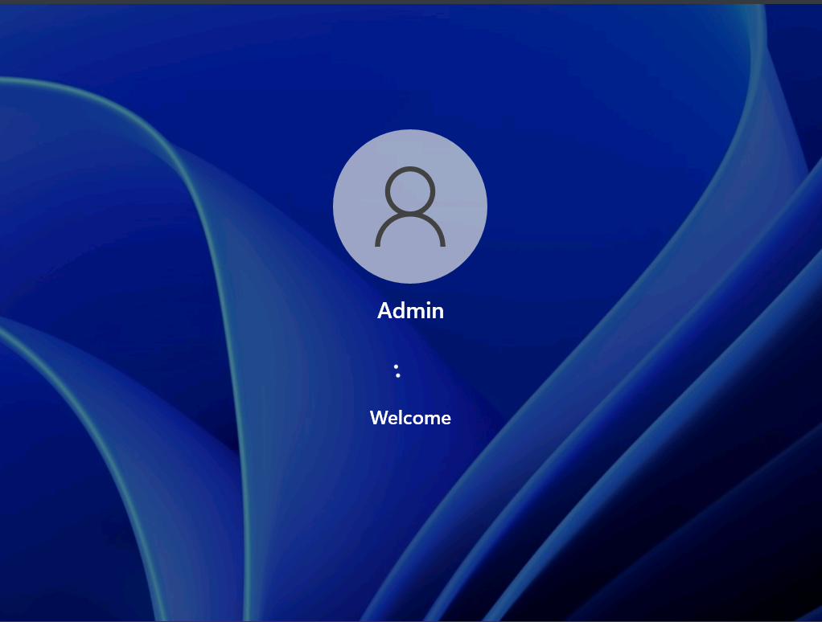

1. Click **File Explorer** at the bottom of the task bar and navigate to [**E:\Labfiles**](urn:gd:lg:a:send-vm-keys).

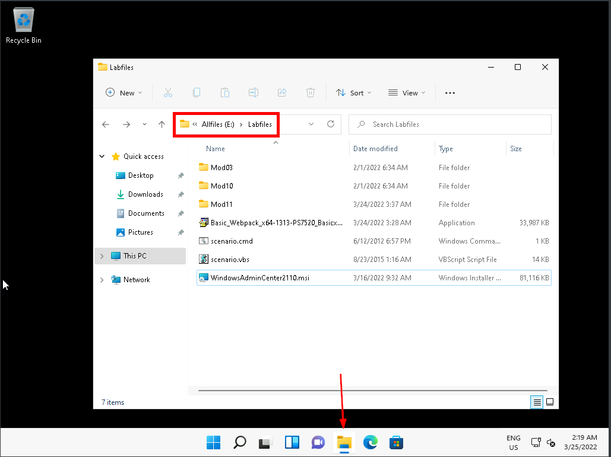

1. Double click **WindowsAdminCenter2110.msi** to launch the installation process.

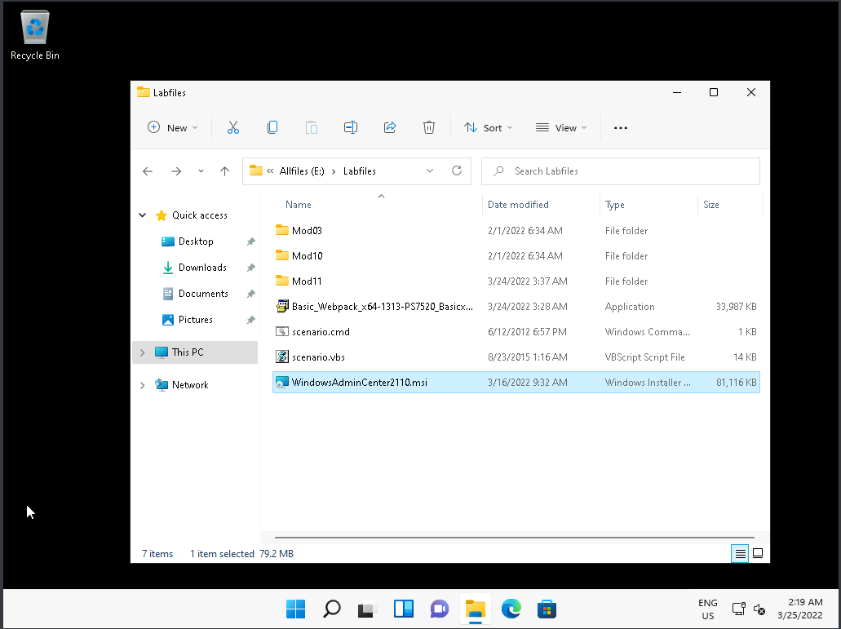

1. On the **Windows Admin Center Setup** Window, click **I accept these terms** then select **Next**.

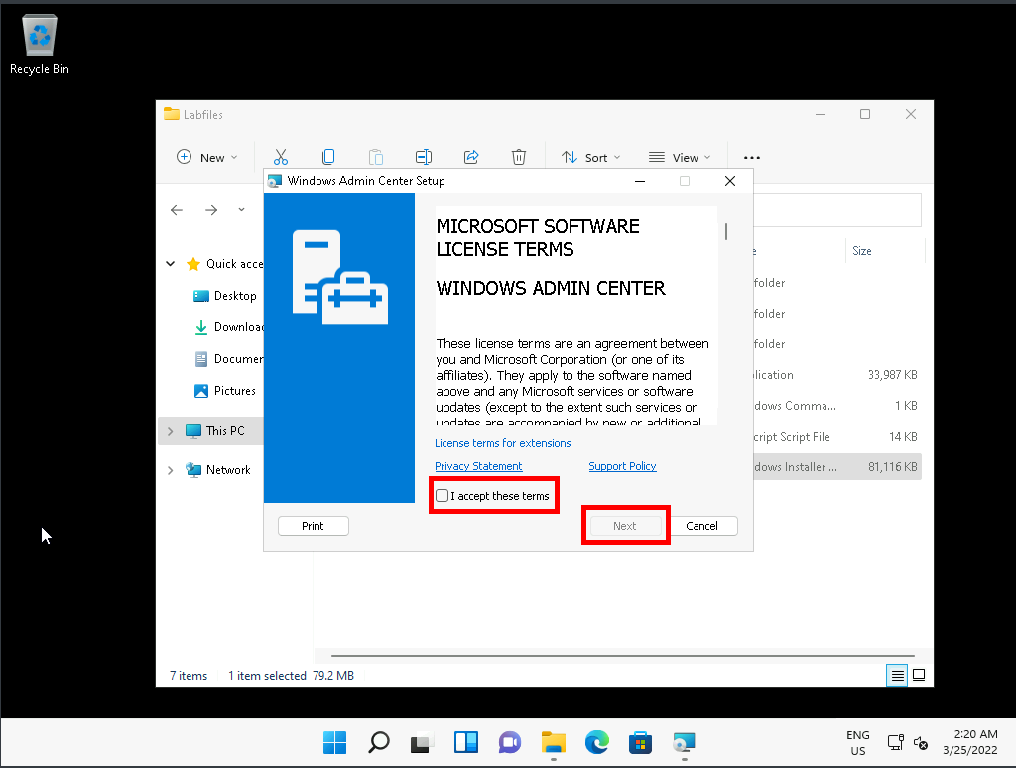

1. On the **Configure Gateway Endpoint** window, leave the default settings and click **Next**

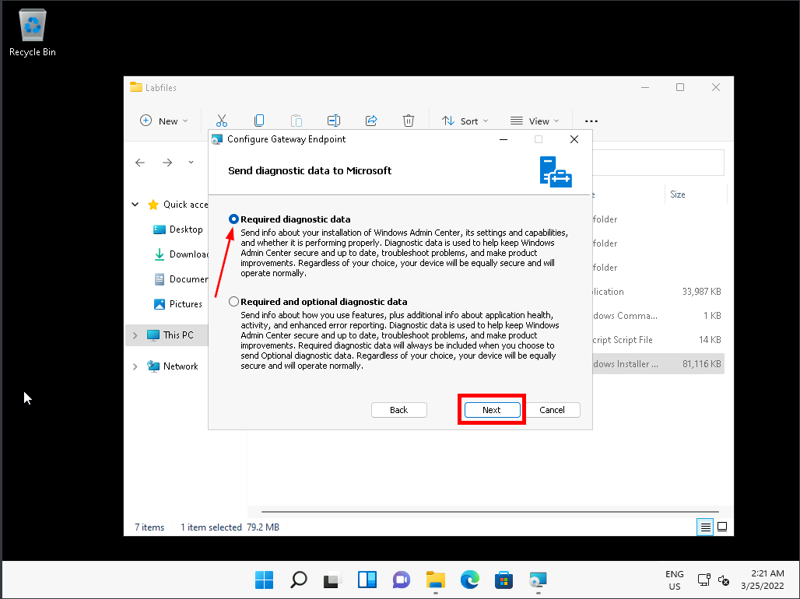

1. On the **Use Microsoft update to help keep your computer secure and up-to-date** window, select **I don't want to use Microsoft Update** and click **Next**.

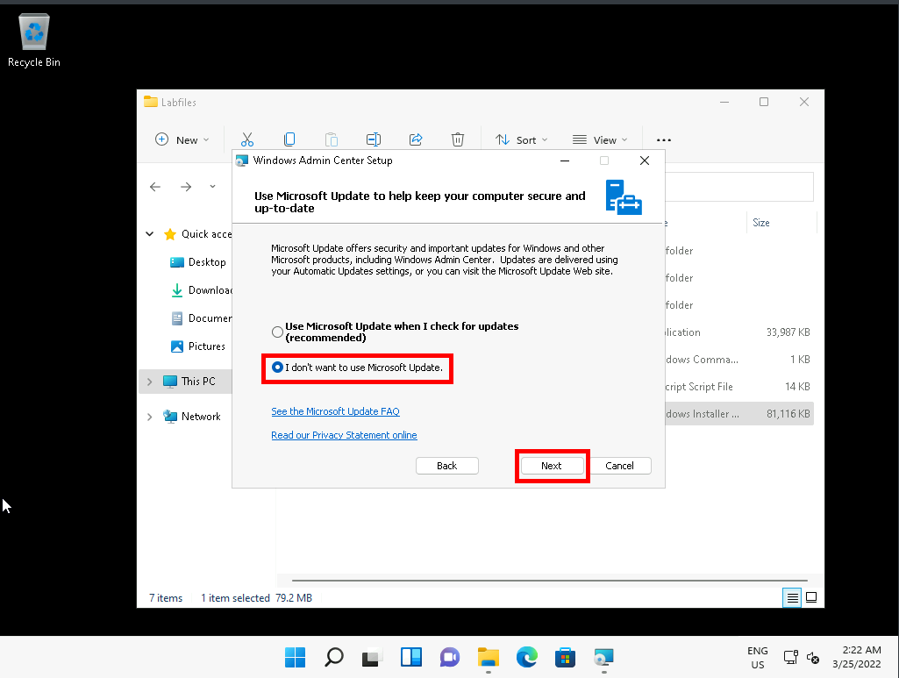

1. On the **Install Windows Admin Center on Windows 10** window, click **Next**.

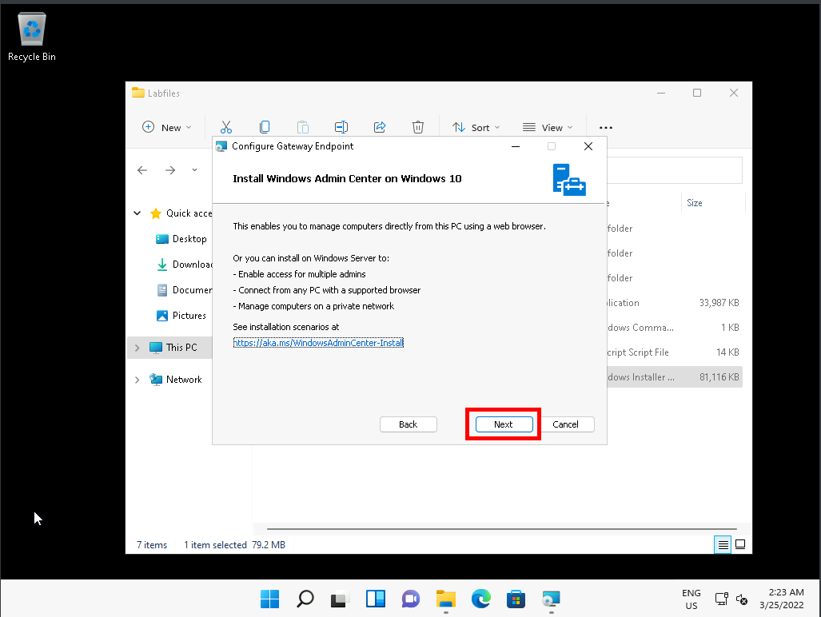

1. On the **Install Windows Admin Center** window, leave the settings as default and click **Install**.

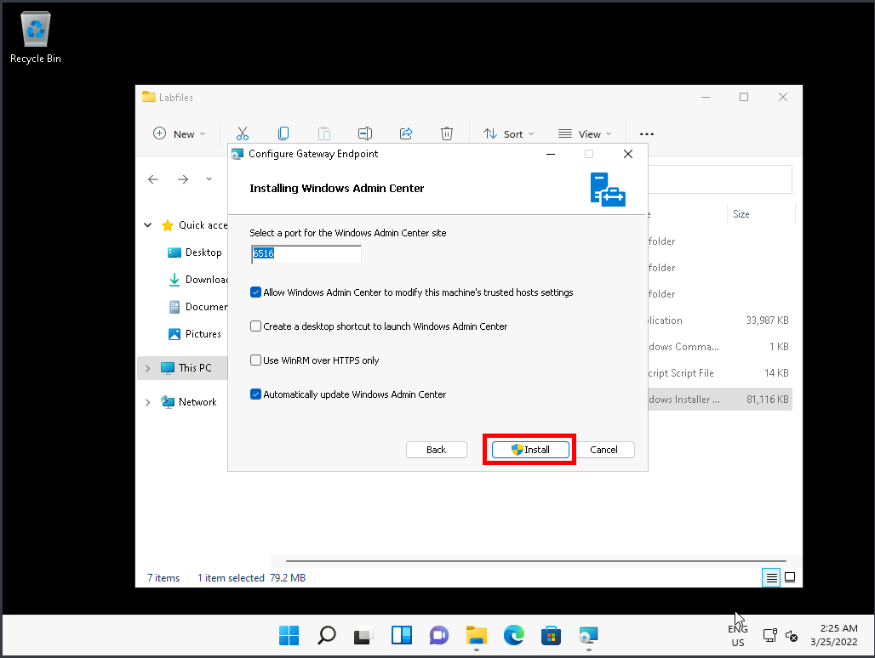

1. On the **User Account Control** Prompt window, click **Yes**.

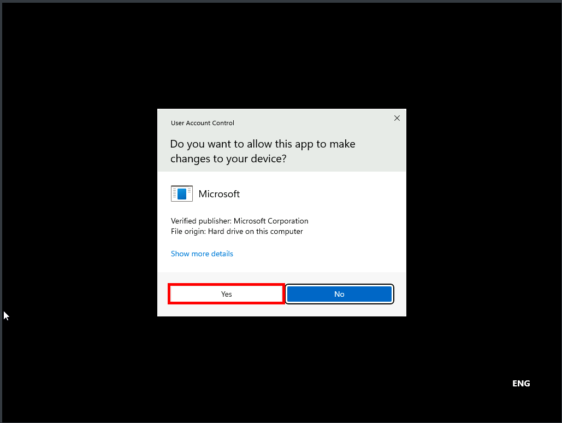

1. Once the installation process have finished, on the **Windows Admin Center Setup** Window select **Finish**.

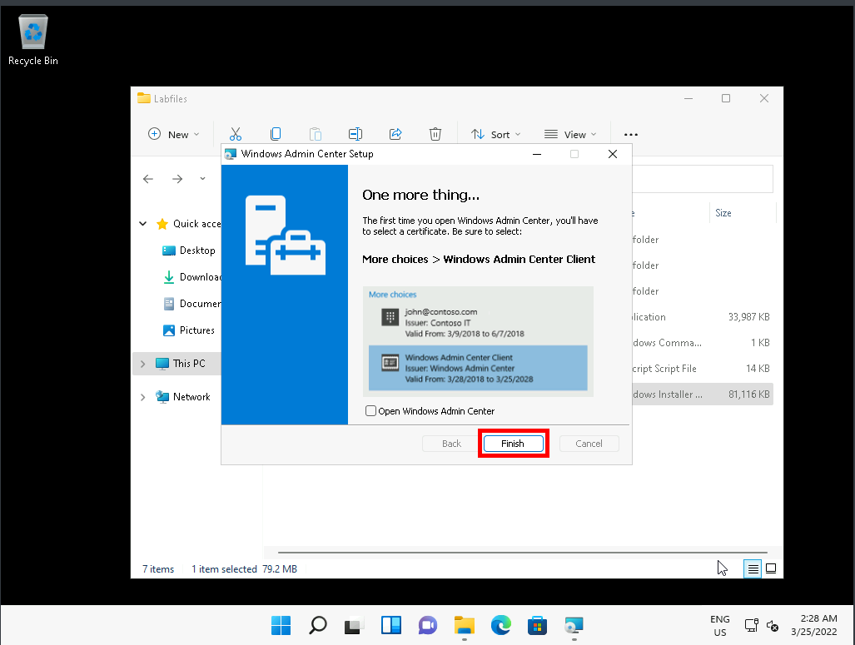

1. Click **Start**, type [**Windows Admin Center**](urn:gd:lg:a:send-vm-keys), and then press **Enter**.

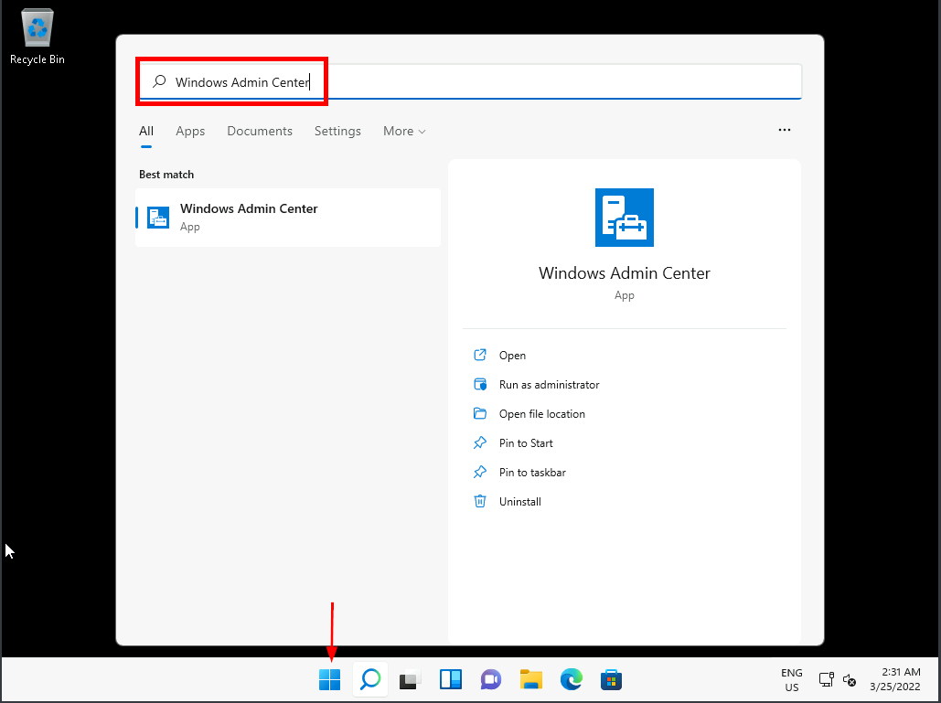

1. If prompted, Click **Ok** on the **Select a certificate for authentication** window.

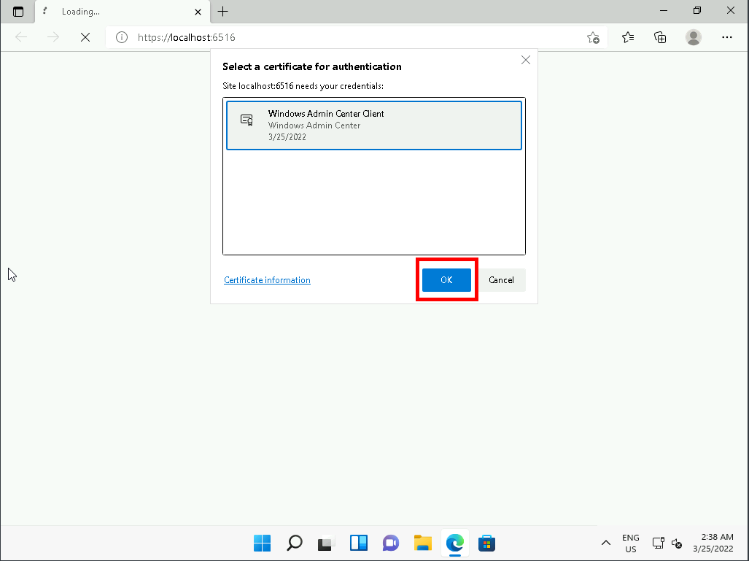

1. If prompted by **User Account Control**, click **Yes**.

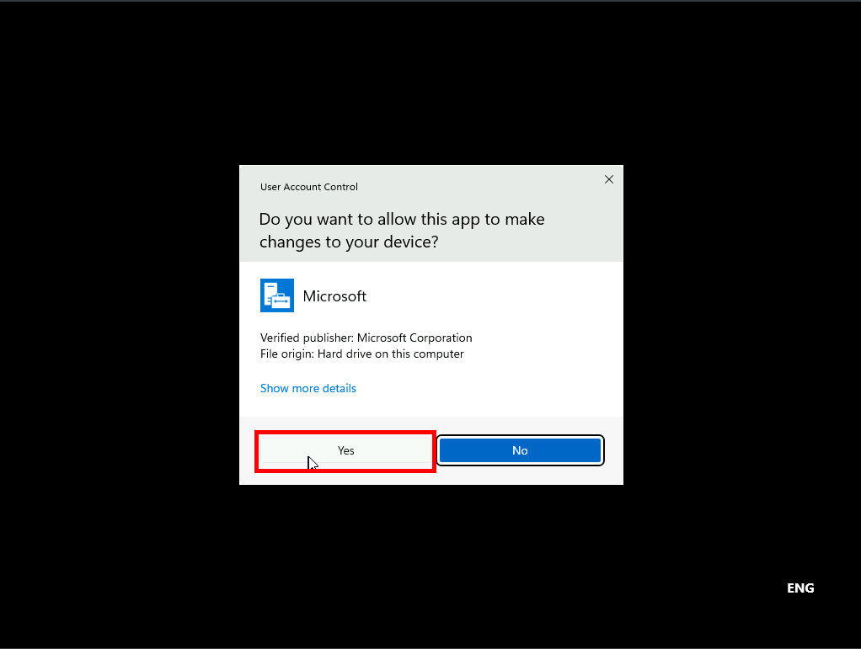

1. In Windows Admin Center, notice that you can see LON-CL1 listed.

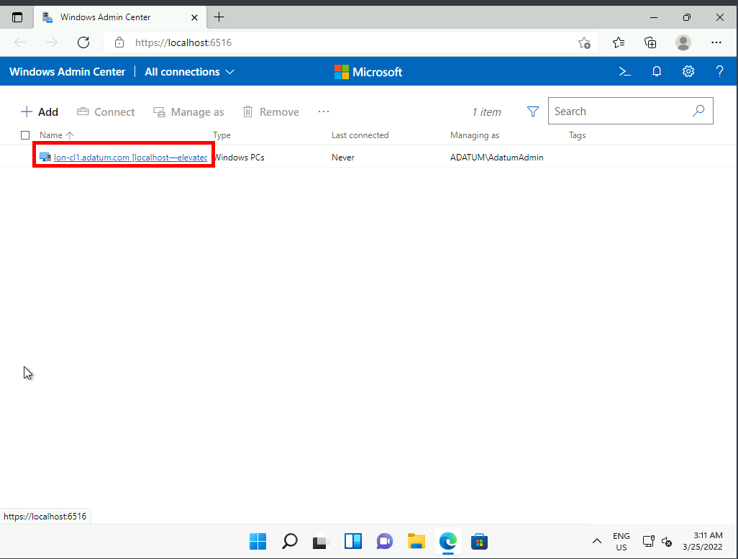

1. Click **+Add**.

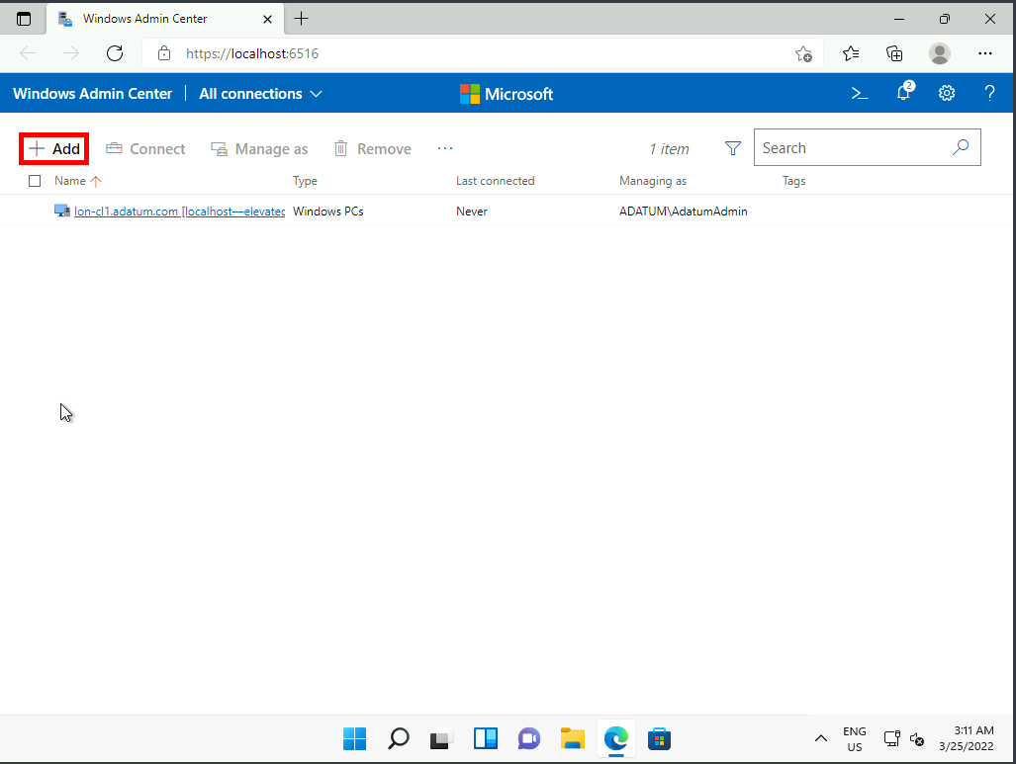

1. In the **Add or create resources** window, under **Servers**, click **Add**.

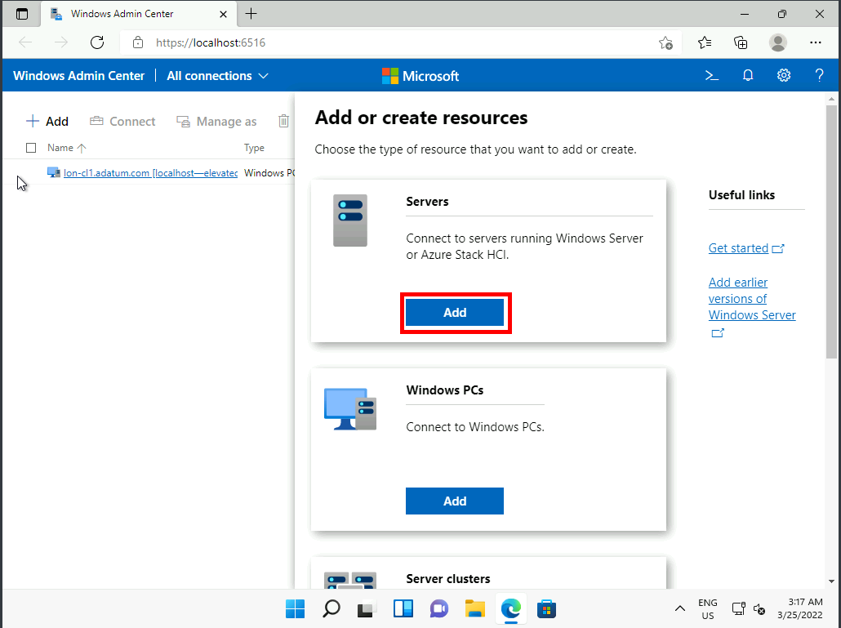

1. In the **Server name** box, enter [**LON-DC1.adatum.com**](urn:gd:lg:a:send-vm-keys).

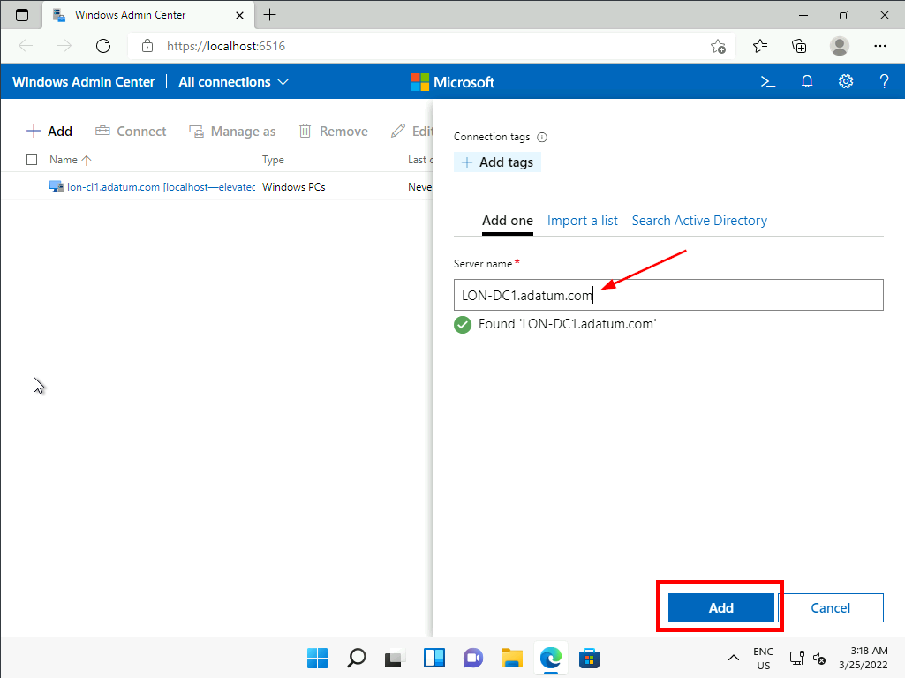

1. Click **+Add**.

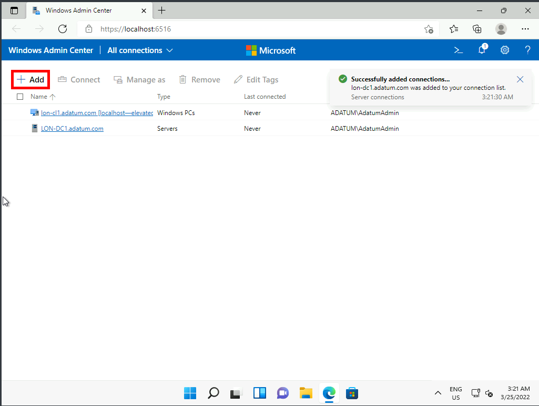

1. In the **Add or create resources** window, under **Windows PCs**, click **Add**.

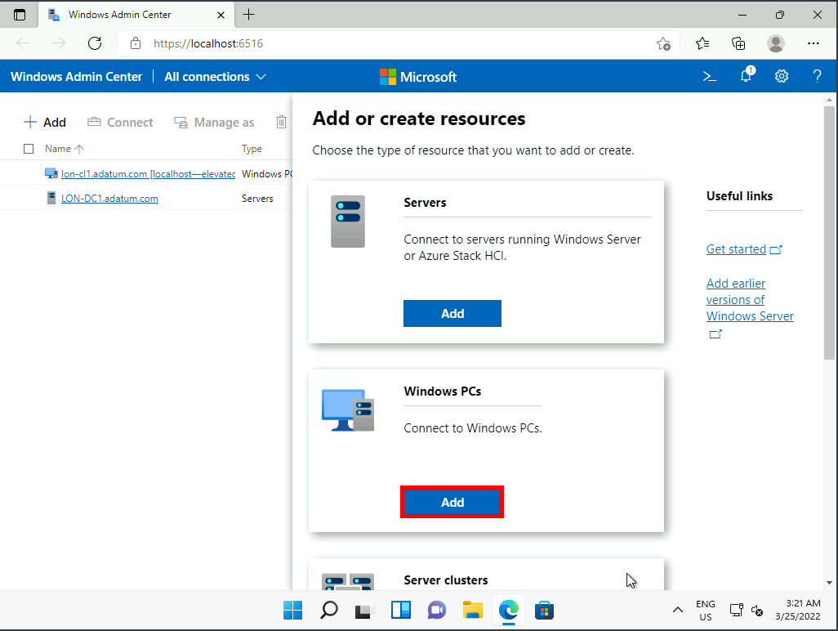

1. In the **Computer name** box, enter [**LON-CL2.adatum.com**](urn:gd:lg:a:send-vm-keys) and click **Add**.

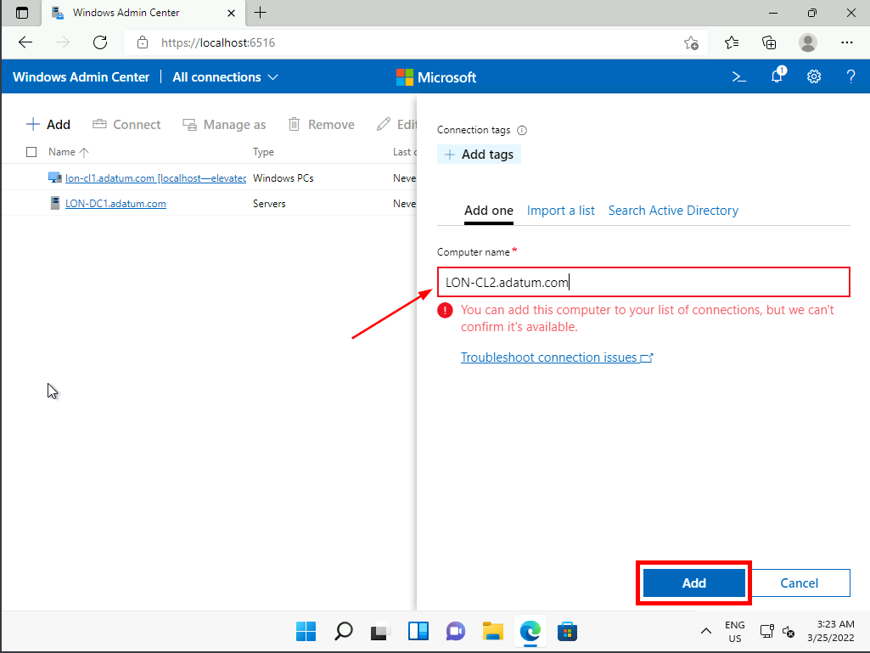

Task 2: Review available options on a remote server

1. In the list of devices, click **LON-DC1.adatum.com**.

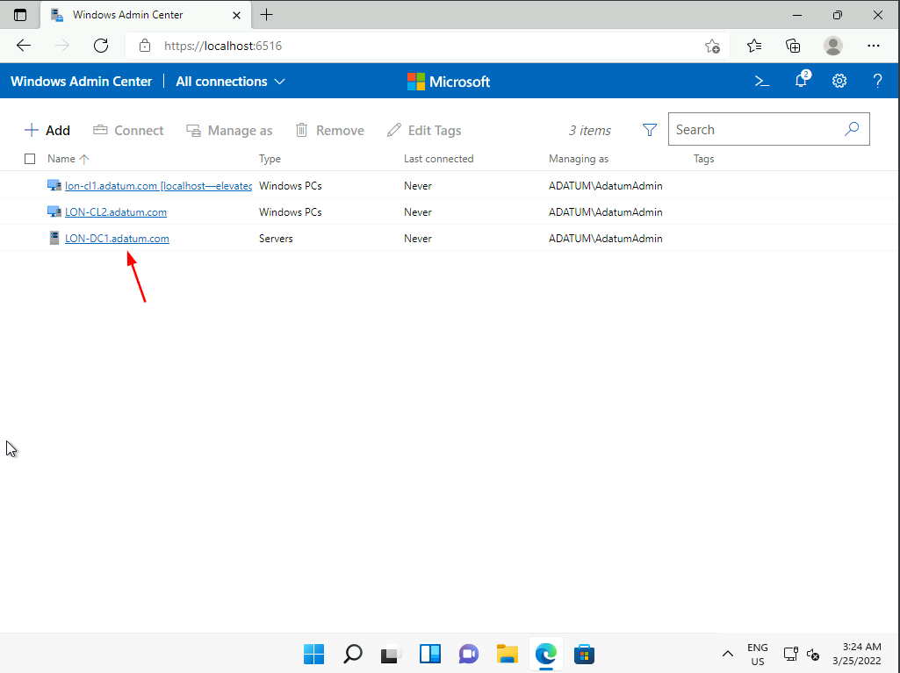

1. On the **Overview** tab, review the available options.

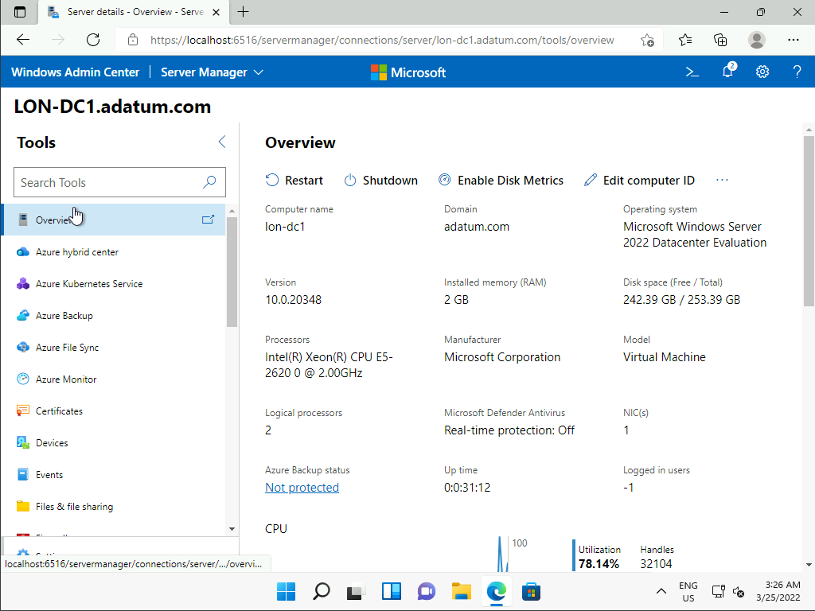

1. In the navigation pane, select **PowerShell**.

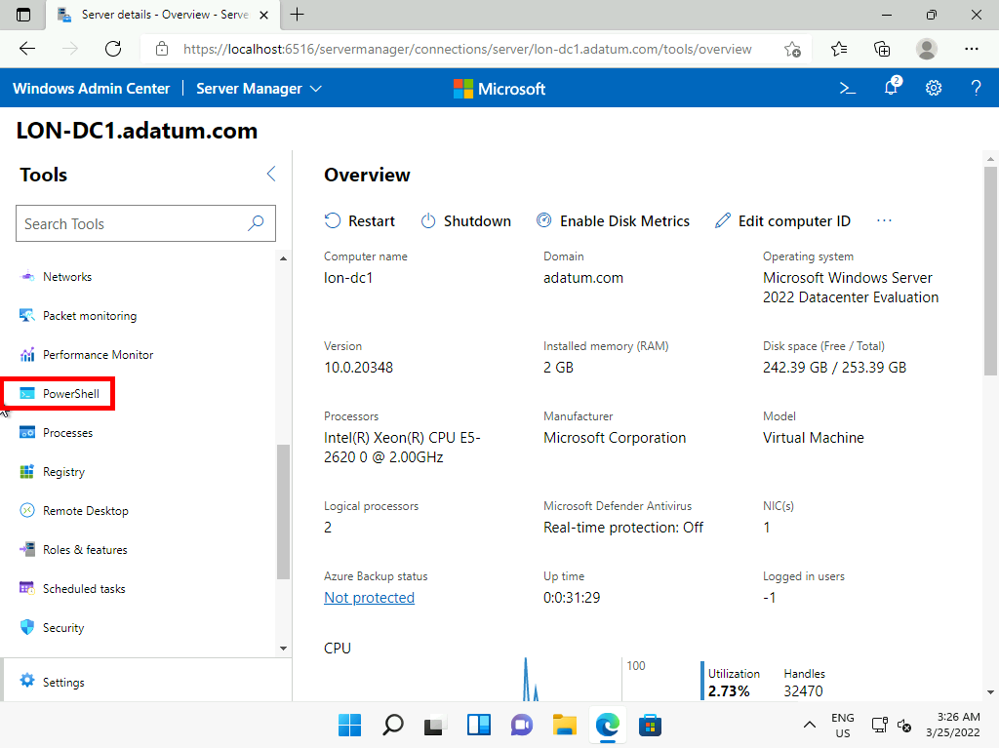

1. If prompted, enter the password of [**Pa55w.rd**](urn:gd:lg:a:send-vm-keys).
2. At the PowerShell prompt, run:
3. hostname

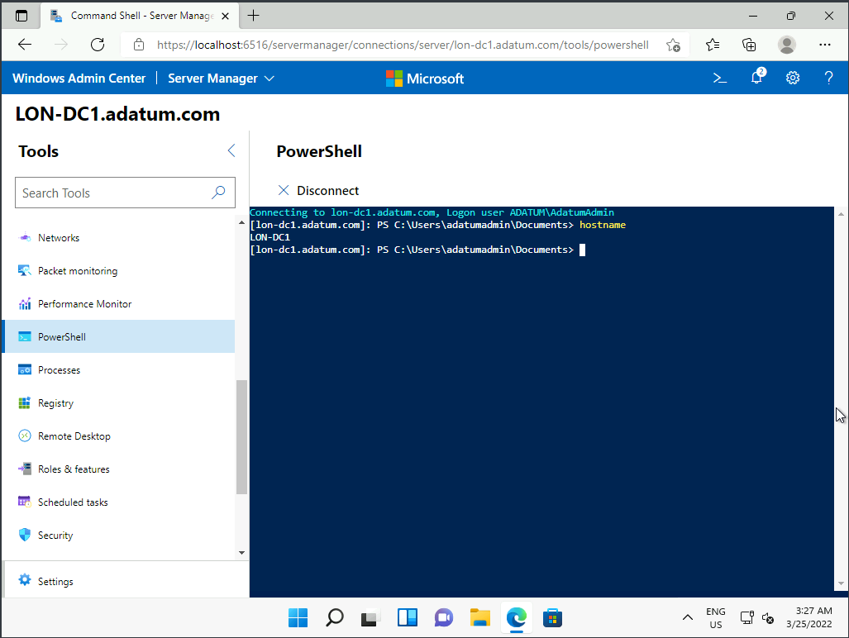

1. At the PowerShell prompt, run:
2. get-netipconfiguration

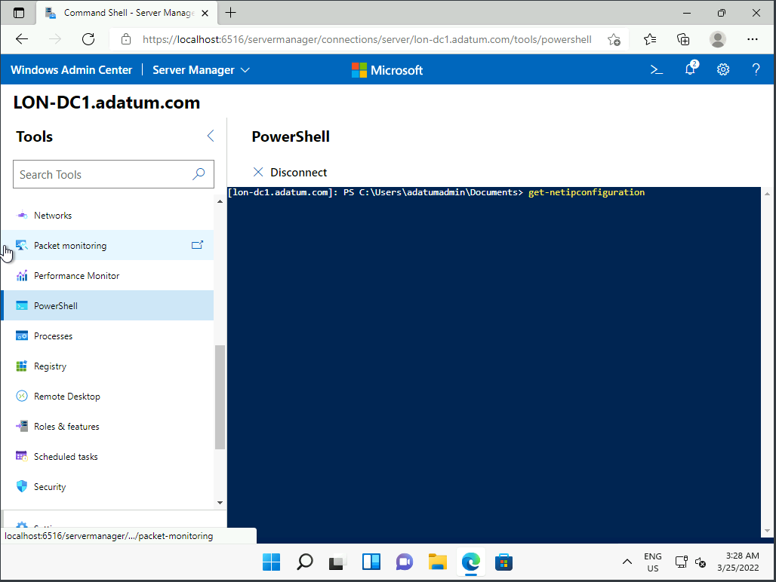

1. At the PowerShell prompt, run:
2. get-ADuser -filter * | ft

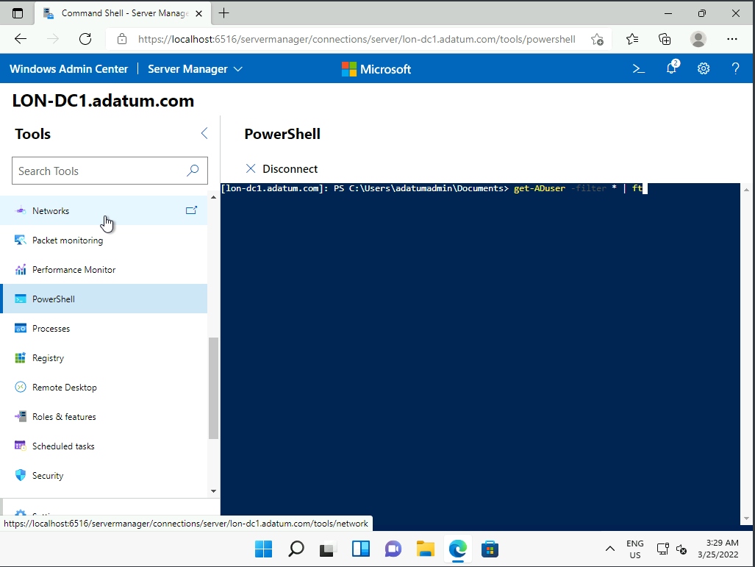

1. At the PowerShell prompt, run:
2. get-service | where-object {$_.status -eq 'running'}

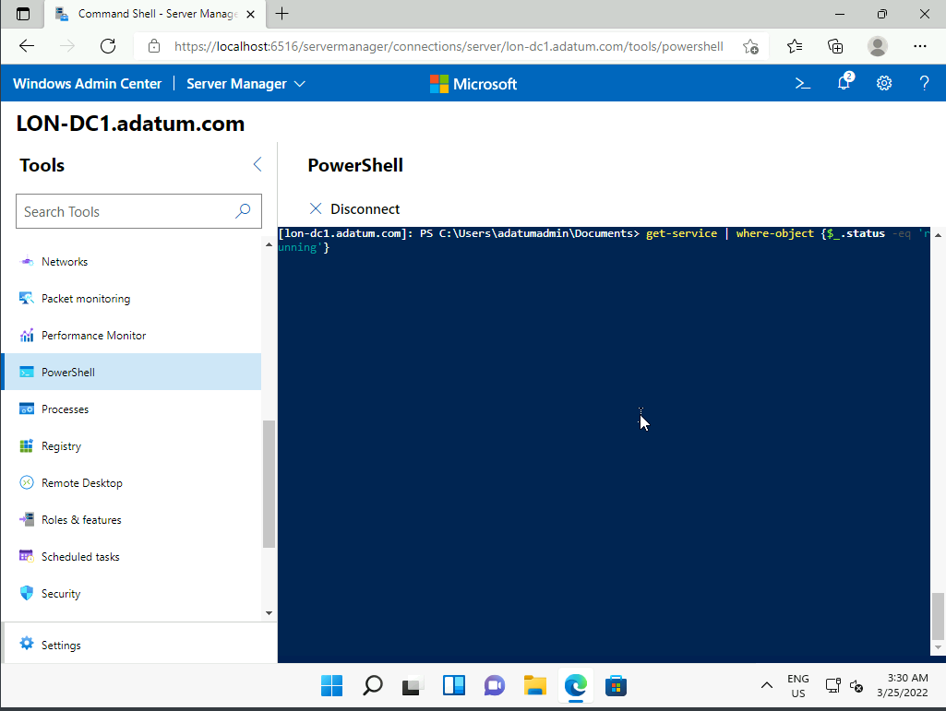

1. In the navigation pane, select **Files & file sharing**, and click **Continue** when prompted.

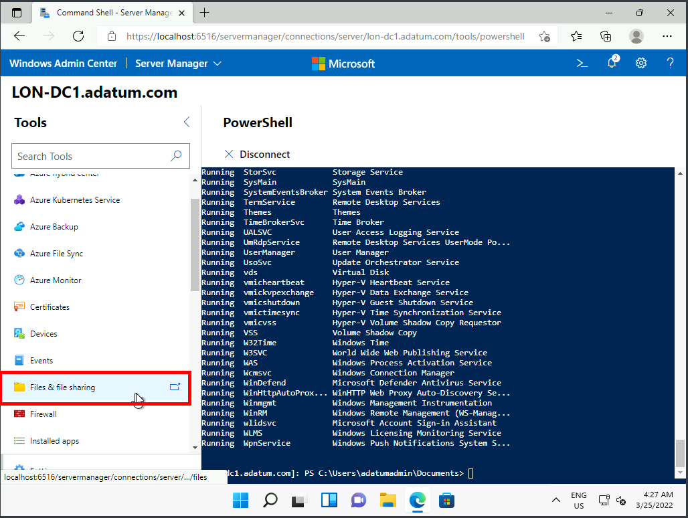

1. Select the **File shares** tab. Review the available shared folders.

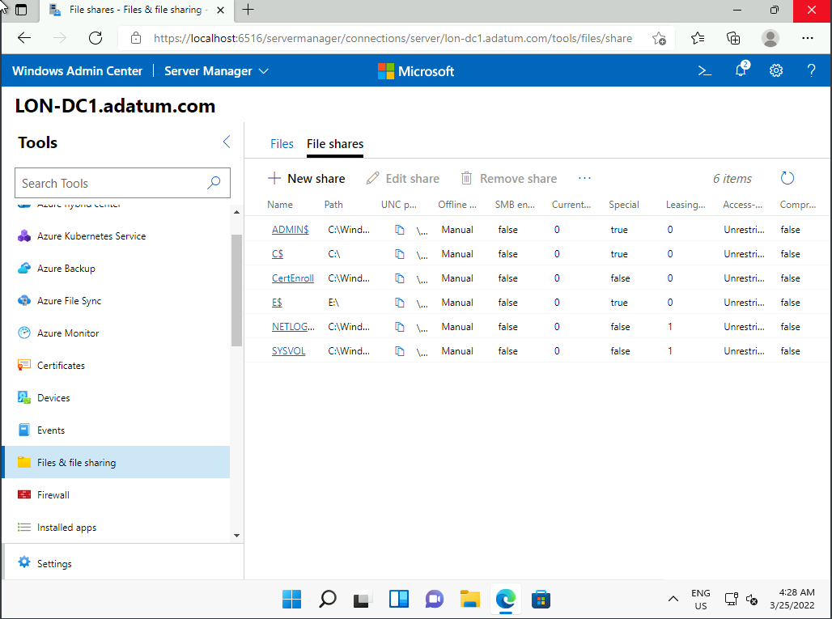

1. In the navigation pane, select **Events**, and then select the **System** log. Review the listed events.

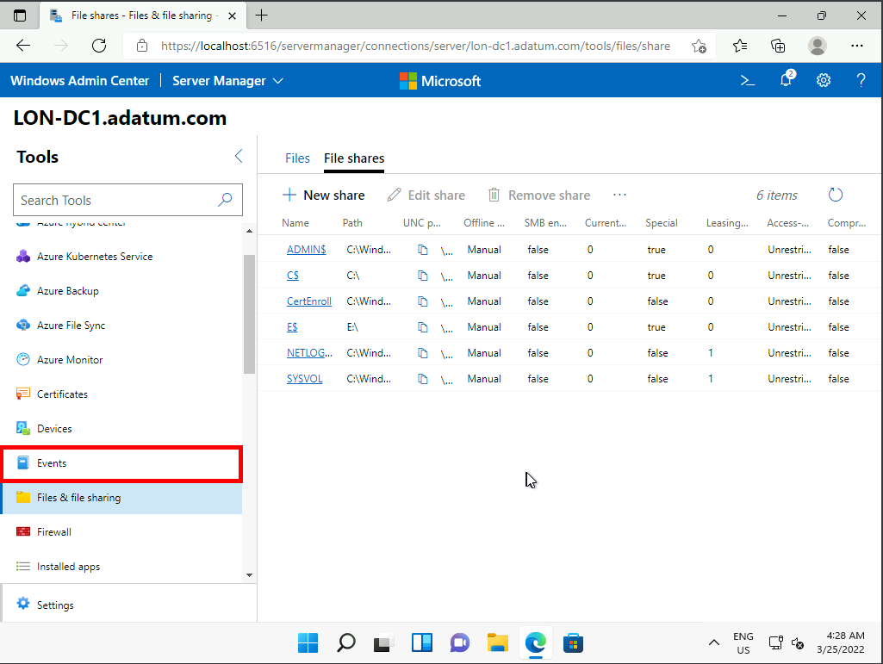

Task 3: Review available options on a remote Windows 11 computer

1. In Windows Admin Center, click the **Windows Admin Center** link above the server name **LON-DC1.adatum.com**. This returns you to the list of devices.
2. In the list of devices, click **LON-CL2.adatum.com**.

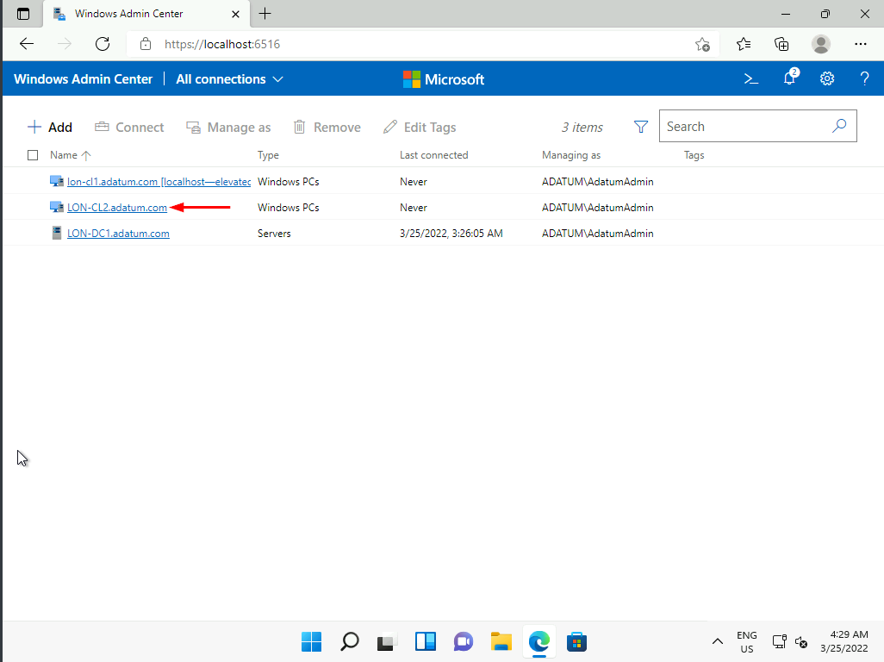

**Note:** You receive a **Connection error** message. This is expected.

1. Click **Close**.

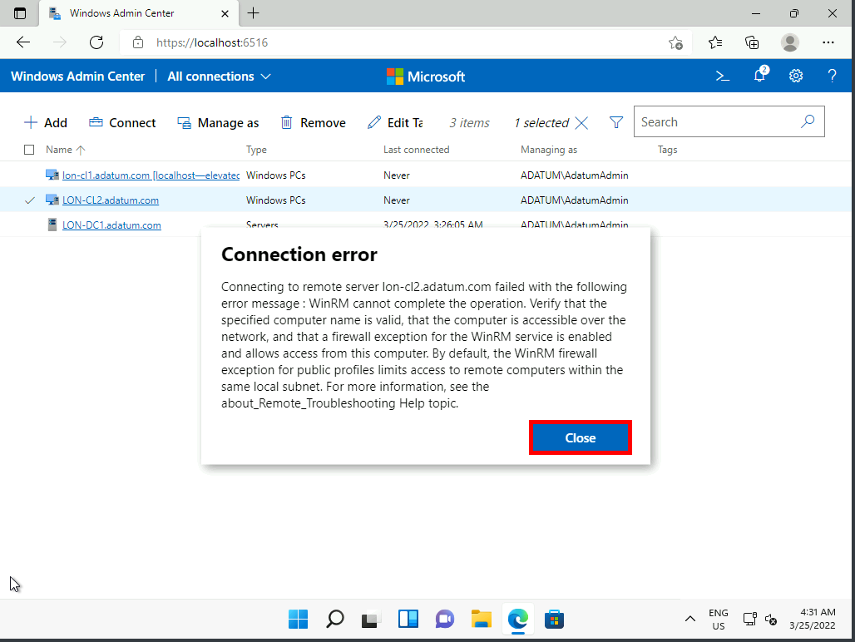

1. Switch to the [**LON-CL2**](urn:gd:lg:a:select-vm) Virtual Machine.
2. Sign in as [**ADATUM\AdatumAdmin**](urn:gd:lg:a:send-vm-keys) with the password [**Pa55w.rd**](urn:gd:lg:a:send-vm-keys).

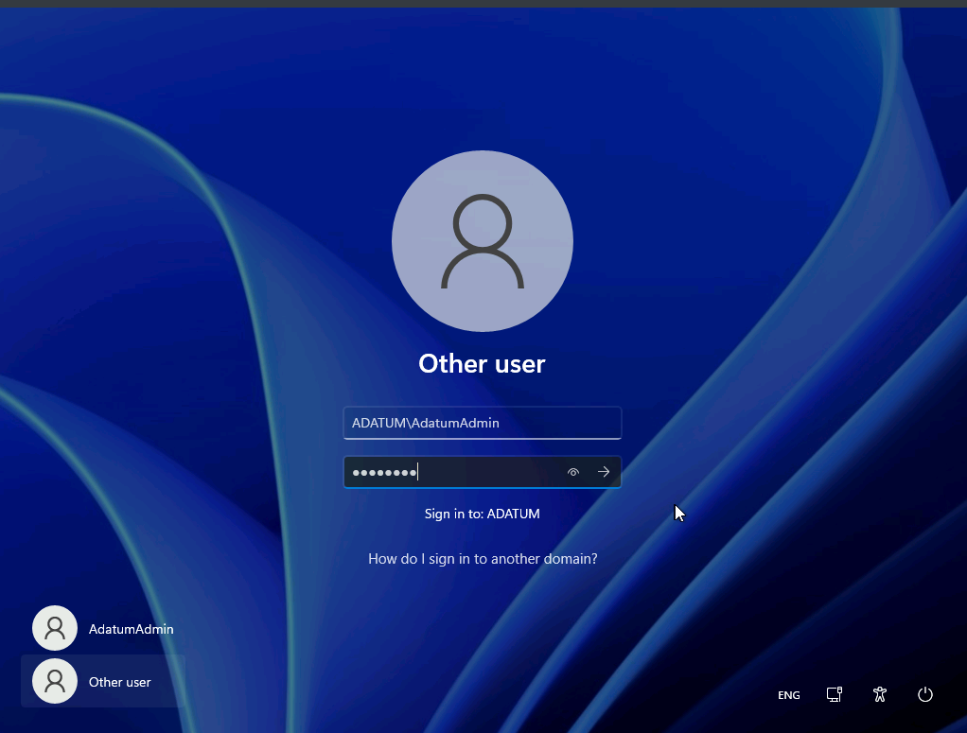

1. Right-click **Start**, and then click **Windows Terminal (Admin)**.

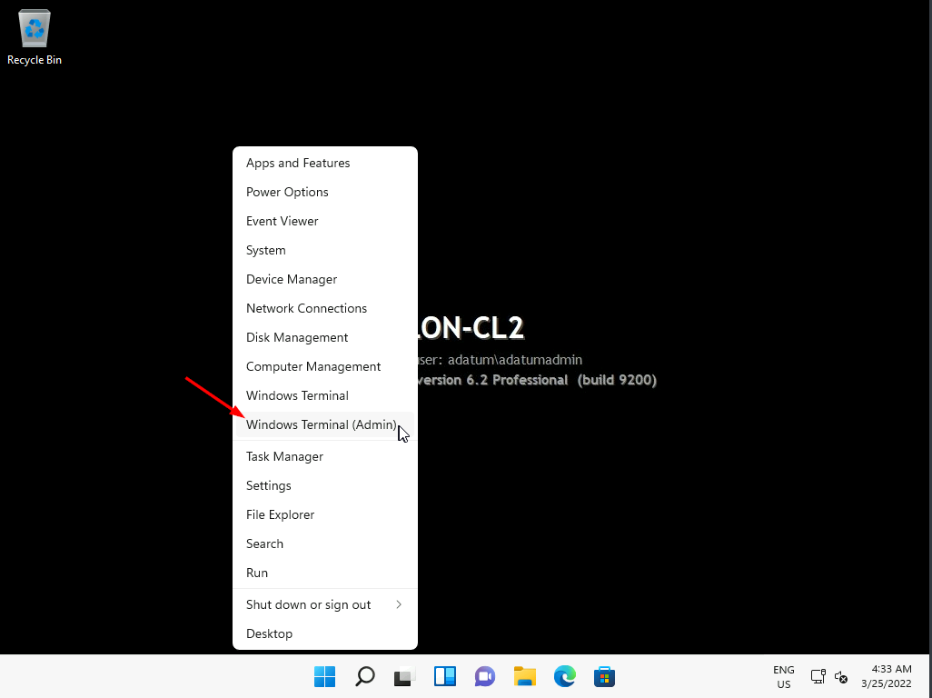

1. At the **User Account Control** prompt, click **Yes**.

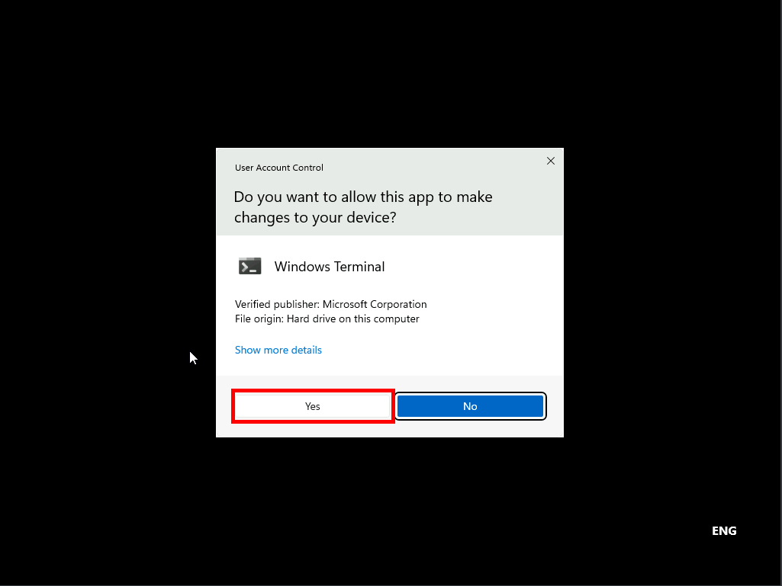

1. At the Administrator: Windows PowerShell command prompt, run the following command: [**enable-psremoting -force**](urn:gd:lg:a:send-vm-keys).

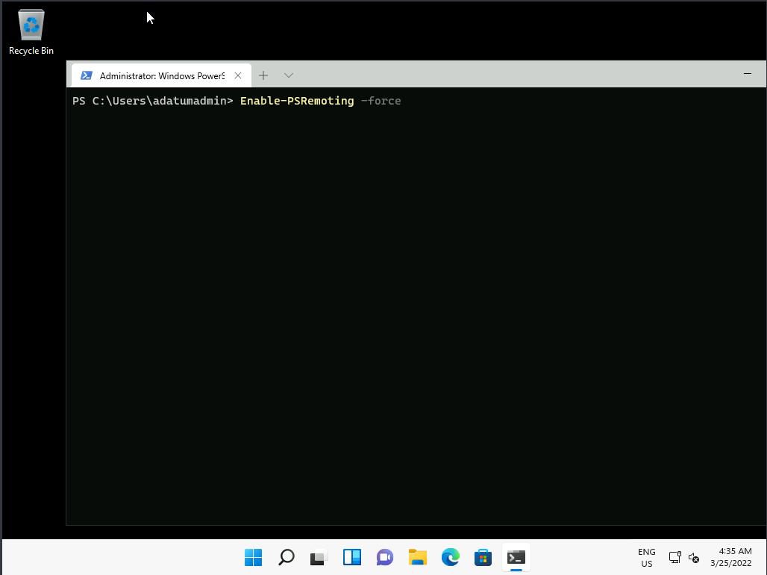

**Note:** This enables the firewall exception required for remote management and also starts the WinRM listener service.

1. From the Home Tab of the LMS, switch to the [**LON-CL1**](urn:gd:lg:a:select-vm) Virtual Machine.
2. In Windows Admin Center, in the list of devices, click **LON-CL2.adatum.com**. Your connection is now successful.

**Note:** The firewall exception and WinRM listener service are enabled by default in Windows Server, but disabled by default on Windows 11.

1. On the **Overview** tab, review the available options.

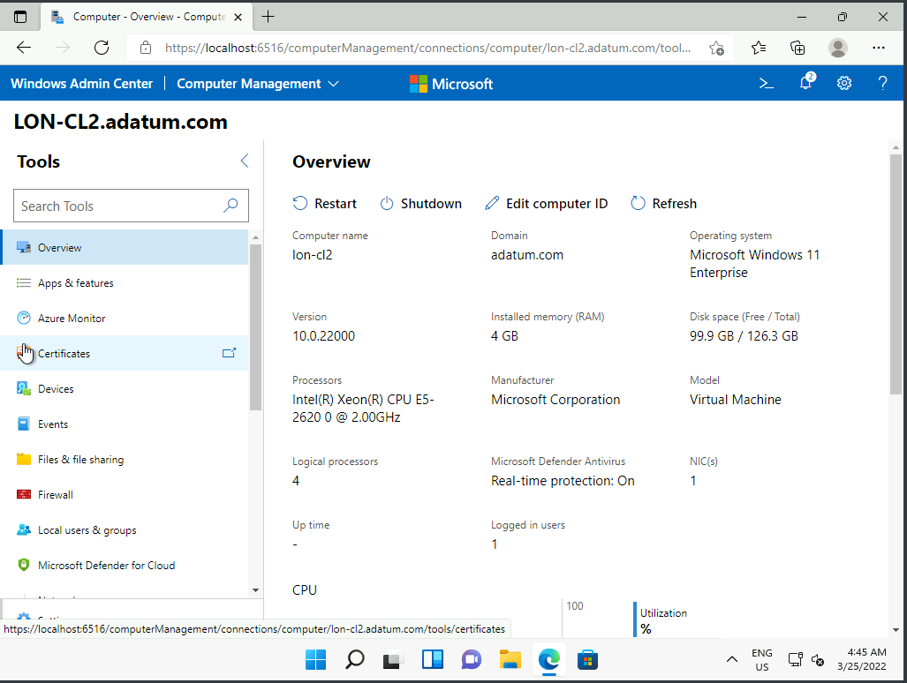

1. In the navigation pane, select **Storage** and then select the **Volumes** tab.

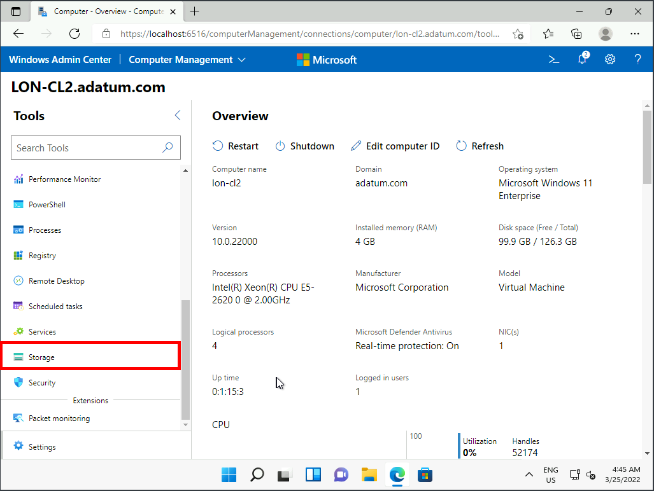

1. Select **(C:)** and review the information displayed.

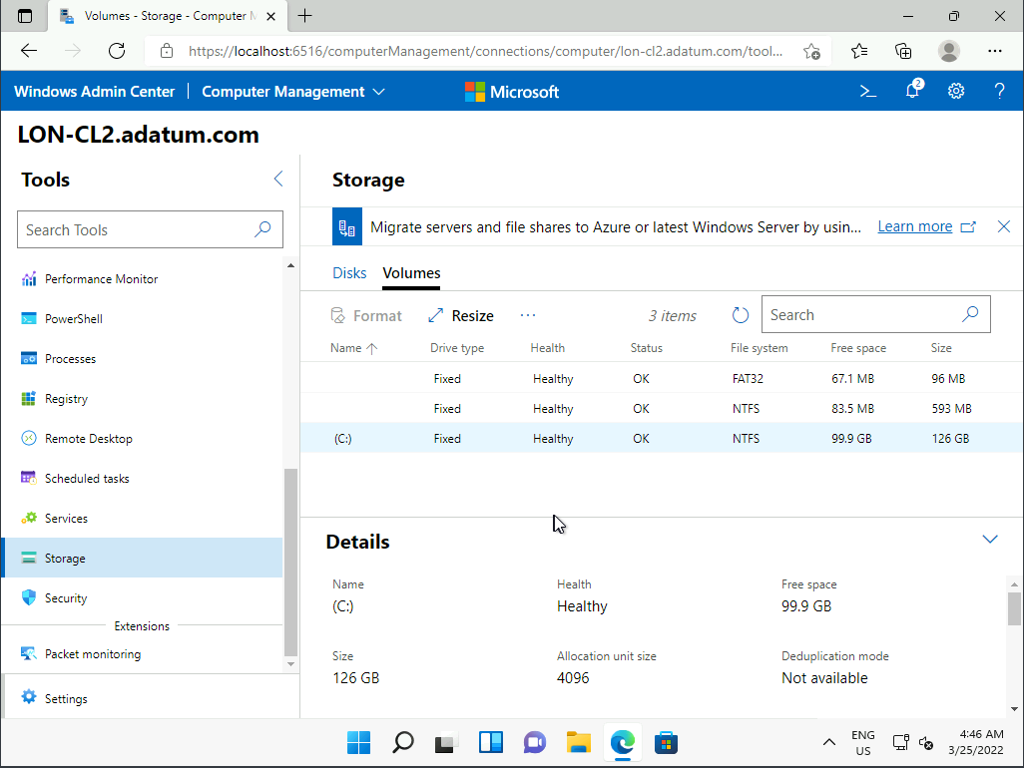

1. Select **PowerShell** in the navigation pane.

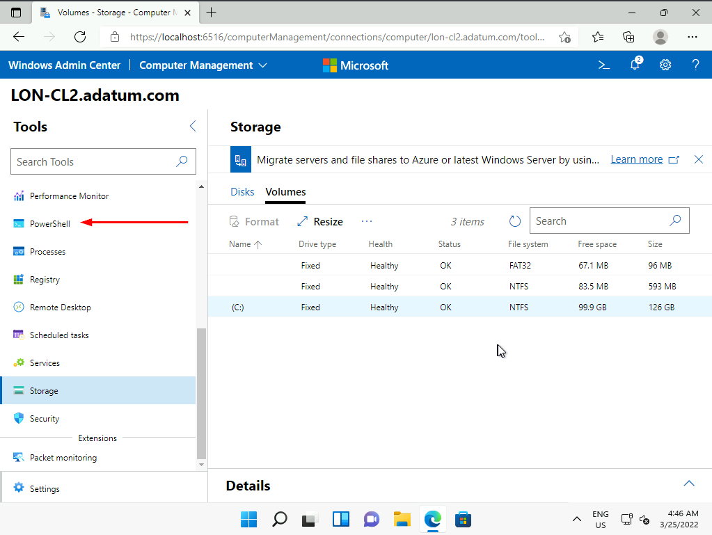

1. Leave Windows Admin Center running.

**Results**: After you complete this exercise, you should have successfully tested Windows Admin Center and reviewed available remote management options.

Exercise 2: Configuring Windows 11 devices with Windows PowerShell

**Scenario**

Your supervisor wants you to use Windows PowerShell to manage devices.

The main task for this exercise is as follows:

* Use Windows PowerShell to configure a device.
* Use Windows PowerShell to remotely manage a device.

Task 1: Use Windows PowerShell to configure a device

1. If necessary, switch to the [**LON-CL1**](urn:gd:lg:a:select-vm) Virtual Machine and sign in as [**ADATUM\AdatumAdmin**](urn:gd:lg:a:send-vm-keys) with the password [**Pa55w.rd**](urn:gd:lg:a:send-vm-keys).
2. Right-click **Start** and then click **Windows Terminal (Admin)**.

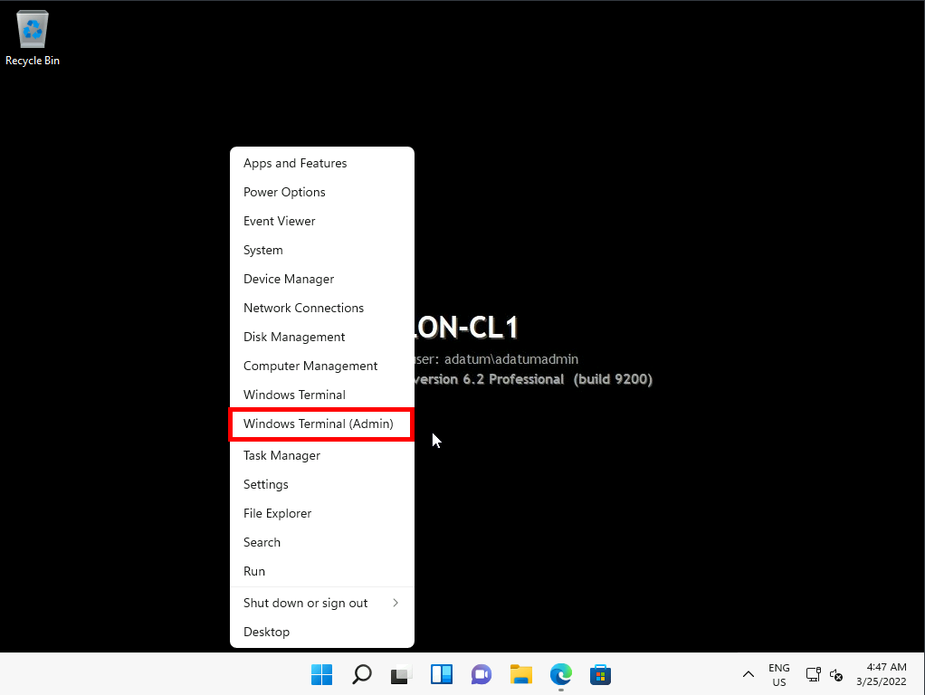

1. At the **User Account Control** prompt, click **Yes**.

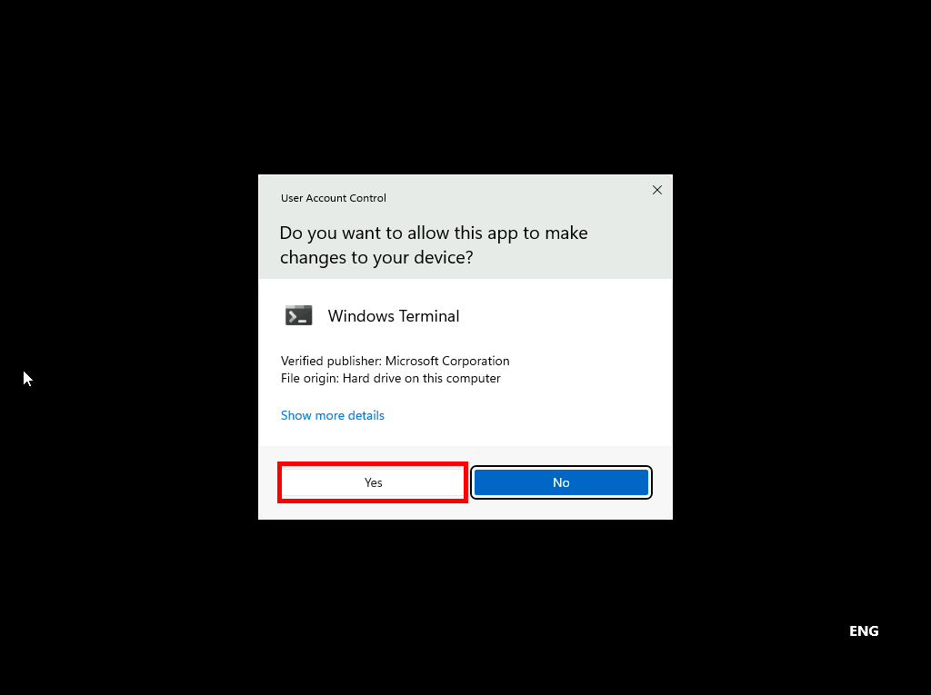

1. Confirm that the current executionpolicy is **Unrestricted**. At the Administrator: Windows PowerShell command prompt, run:
2. Get-ExecutionPolicy

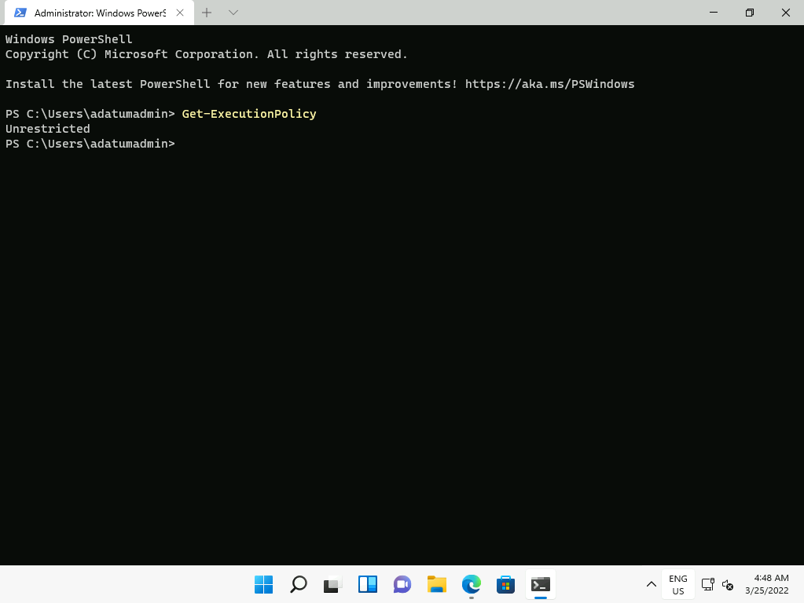

1. Open **Settings**, and select **Bluetooth & devices**.

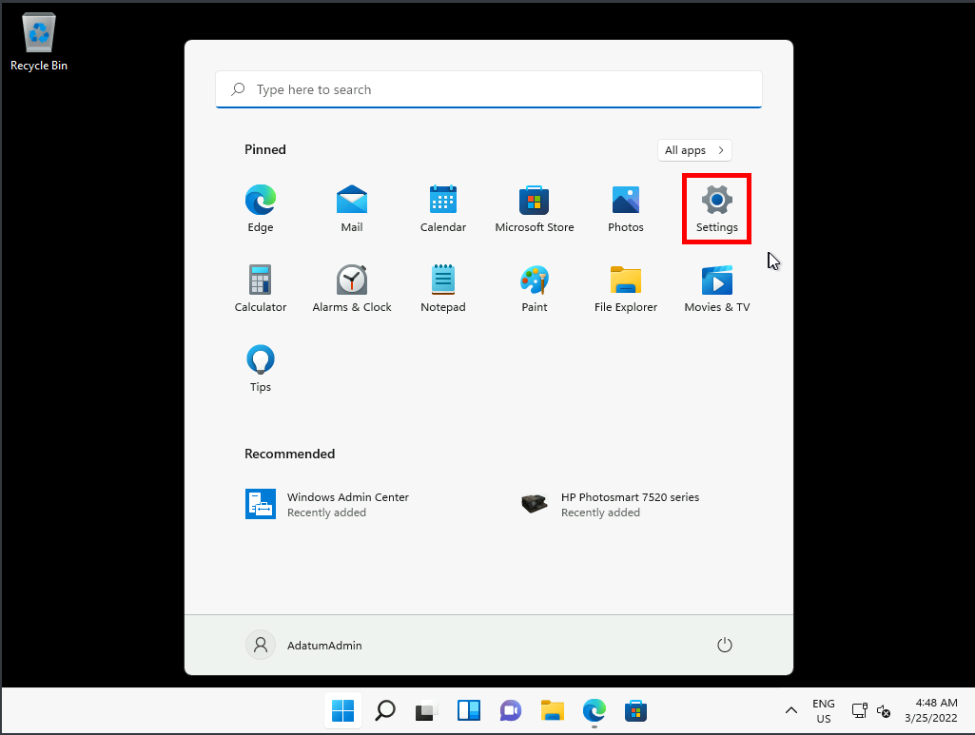

1. Select **Printers & scanners**.

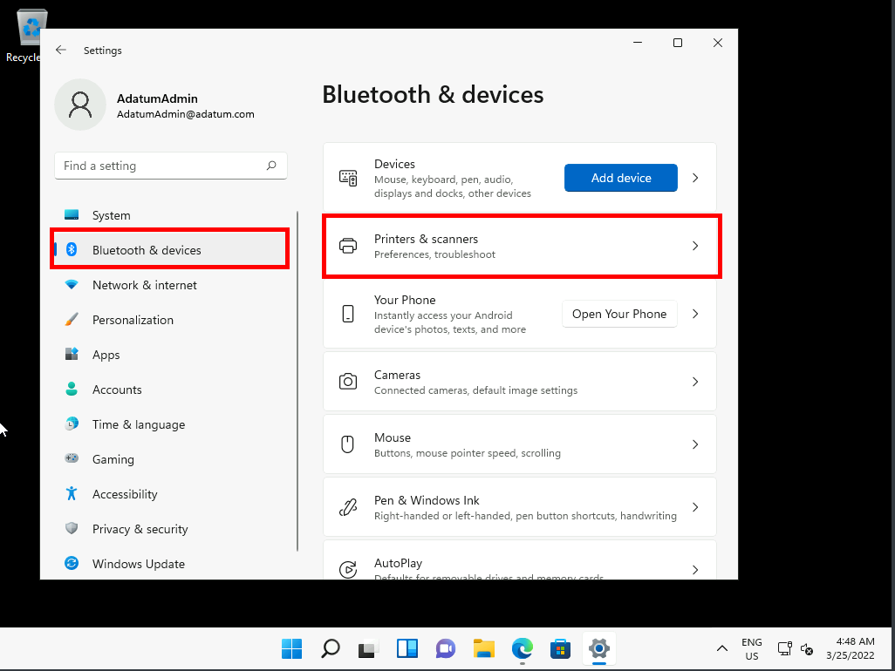

1. Review the available printers, and notice the **HP PhotoSmart 7520** printer.

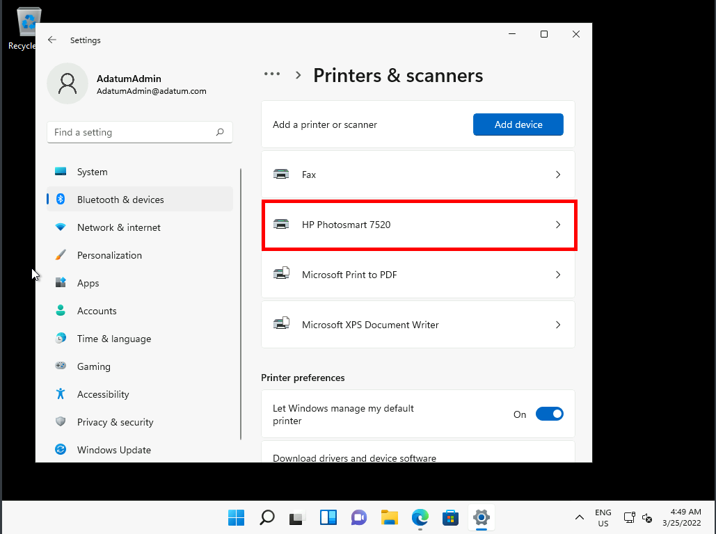

1. Select this printer, and then click **Printing preferences**.

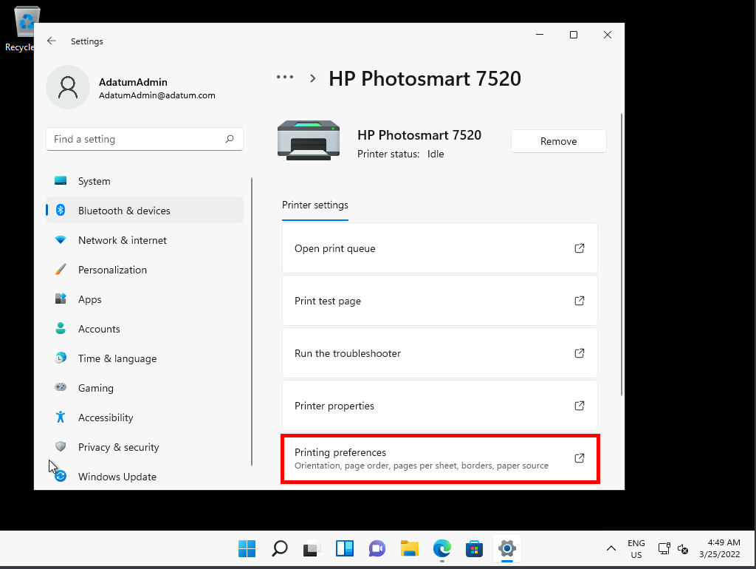

1. In the Print on Both Sides list, click **Flip on Long Edge** and click **OK**.

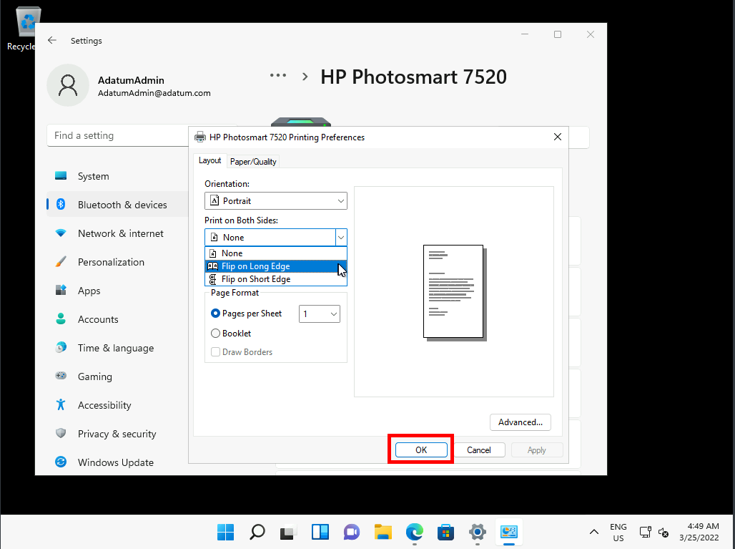

1. Switch to **Windows PowerShell**, and run the following command:
2. Get-PrinterProperty -PrinterName "HP PhotoSmart 7520" | fl

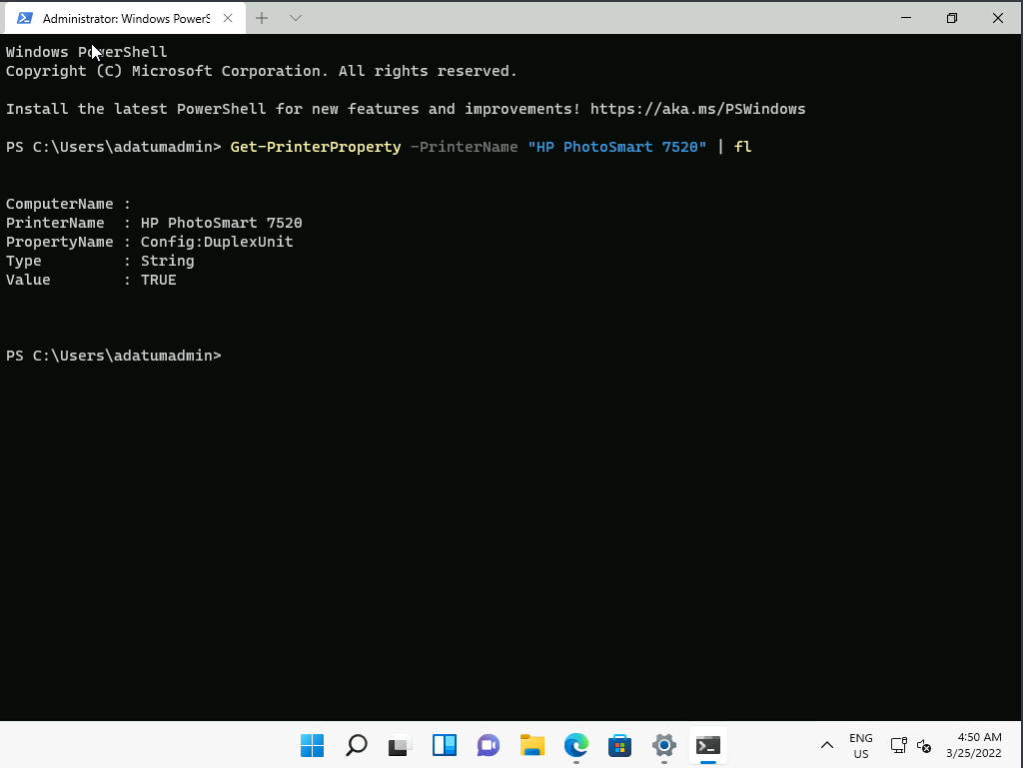

**Note:** The property named **Config:DuplexUnit** is set to TRUE.

1. At the Windows PowerShell command prompt, run the following:
2. Set-PrinterProperty -PrinterName "HP Photosmart 7520" -PropertyName "Config:DuplexUnit" -Value FALSE

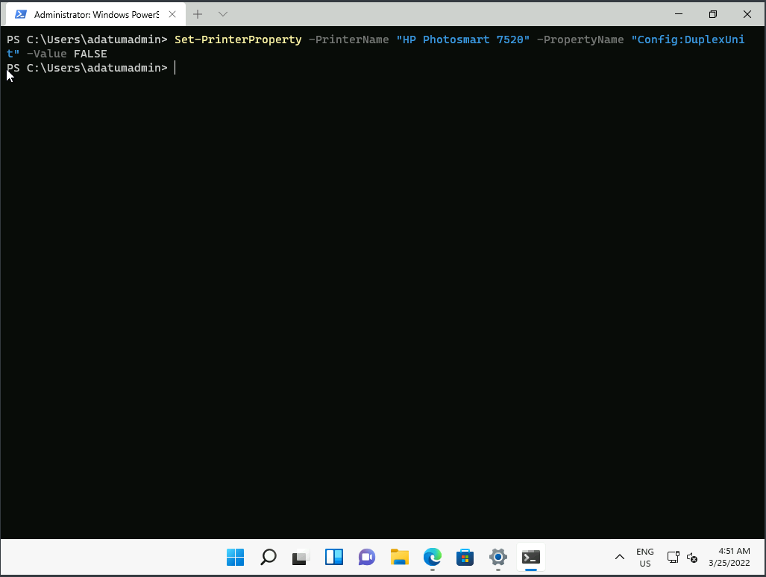

**Note:** You must use all uppercase letters for the TRUE and FALSE values.

**Note:** Note that in Windows PowerShell, each cmdlet parameter name is immediately preceded by a hyphen (-), as with the *-Value* parameter that you just used. However, word wrapping might separate the hyphen from the parameter name when you copy it from a file. Therefore, you need to inspect all copied cmdlets and parameters to ensure that they follow Windows PowerShell syntax requirements.

1. At the Windows PowerShell command prompt, run the following:
2. Get-PrinterProperty -PrinterName "HP Photosmart 7520" | fl

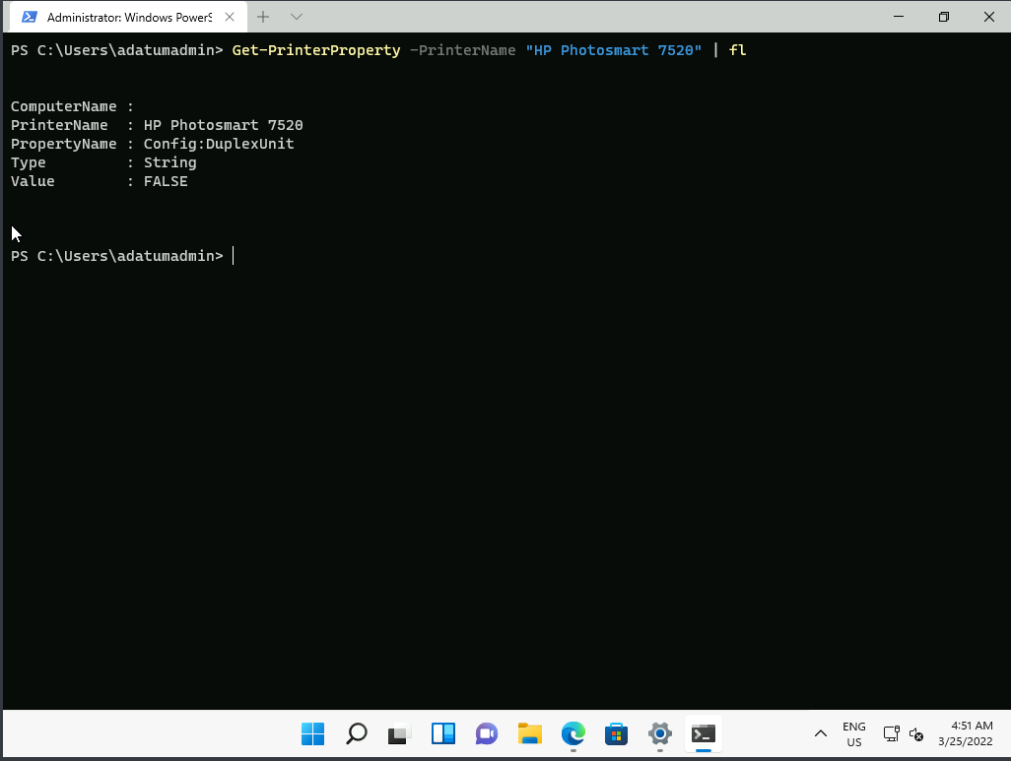

**Note:** The property named **Config:DuplexUnit** is now FALSE.

1. In Settings, in the **HP Photosmart 7520** window, select **Printing Preferences**.

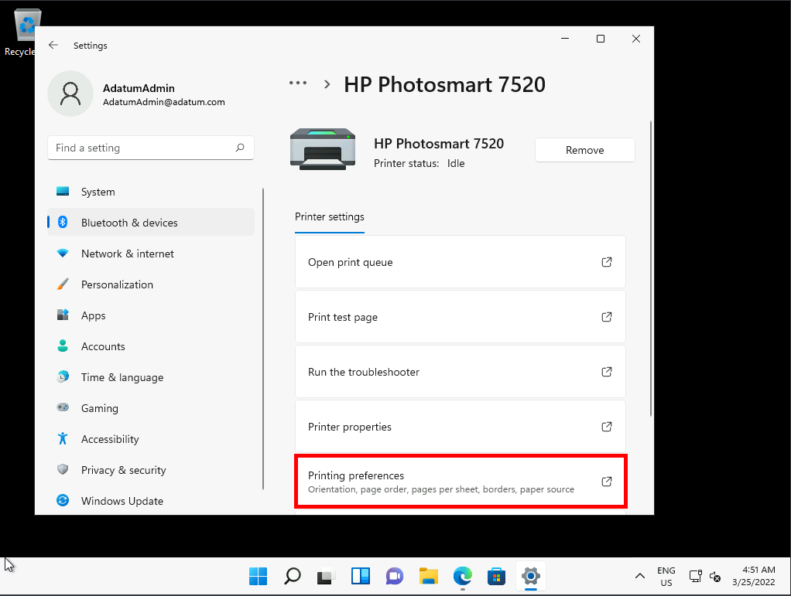

**Note:** In the **HP Photosmart 7520 Printing Preferences** window, note that the **Print on Both Sides** list is gone.

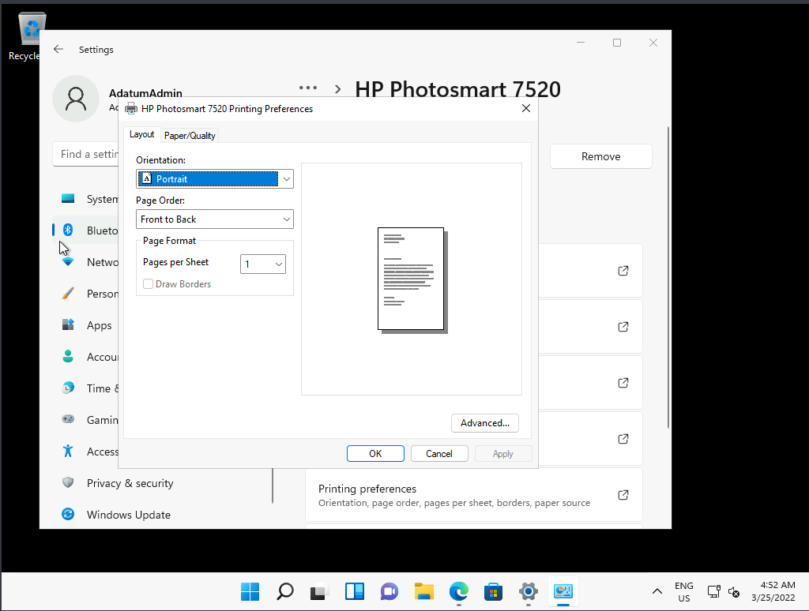

1. Close **Settings**.

Task 2: Use Windows PowerShell to remotely manage a device

1. Switch to **Microsoft Edge** and if necessary, select the **Windows Admin Center** tab.
2. In **Windows Admin Center**, on the **LON-CL2.adatum.com** page, ensure the **PowerShell** tab is selected.
3. Notice the **[lon-cl2.adatum.com]** prefix for the command prompt. This indicates that the session is remote to the indicated computer. You can run any PowerShell cmdlets here, and they'll execute via WinRM on the target device.

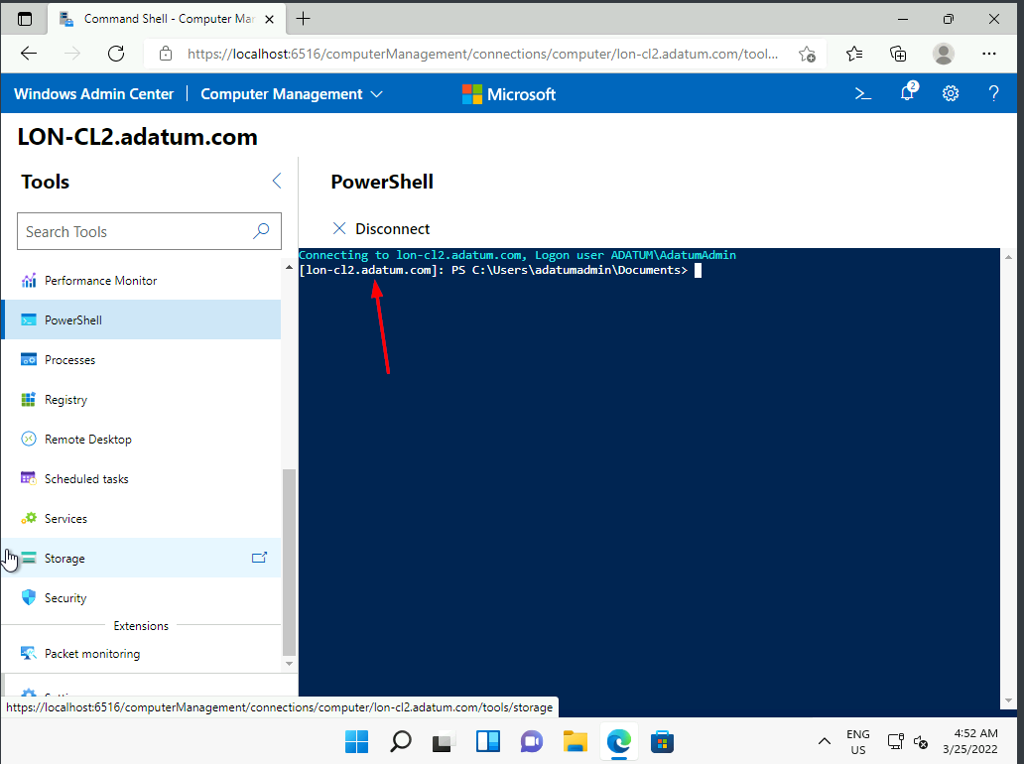

1. Switch to **Windows Terminal**.
2. Run the following command:
3. Enter-PSSession -computername LON-CL2

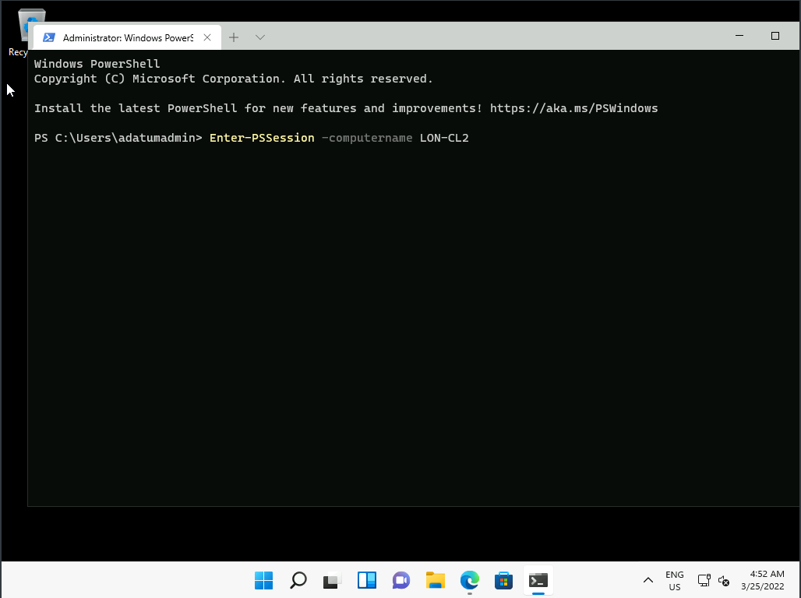

1. Run the following command:
2. hostname

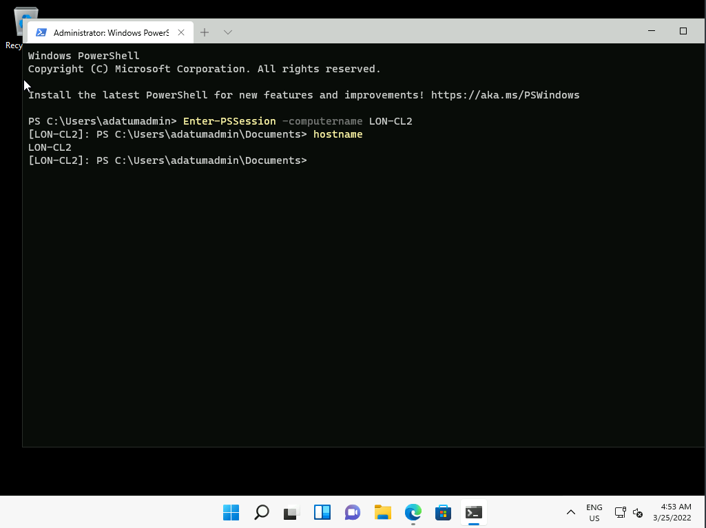

**Note:** Notice you are connected to LON-CL2. Any commands that you run will execute on the remote host.

1. Run the following command to disconnect from LON-CL2:
2. **exit**

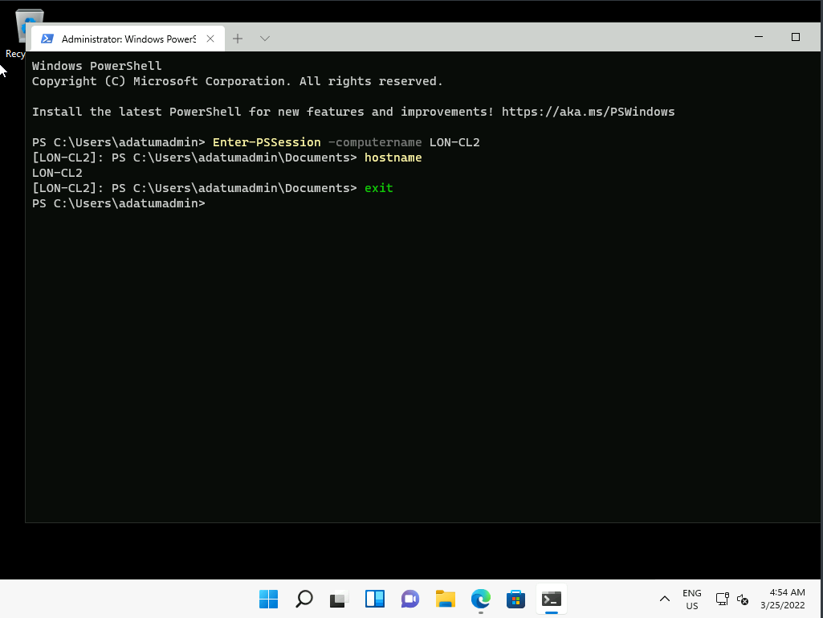

1. To retrieve system event log entries from a remote computer, run the following command:
2. Invoke-Command –ComputerName LON-CL2 –ScriptBlock {Get-EventLog –log system}

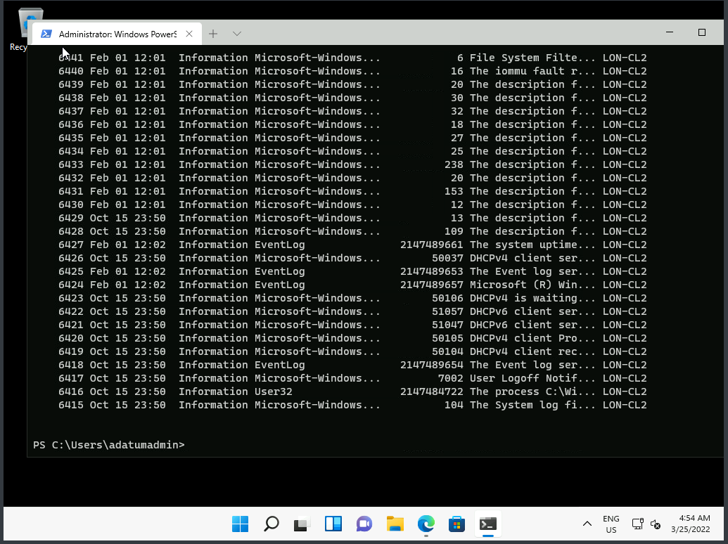

1. to create a remote session on two specified computers, run the following command:
2. $s = New-PSSession –ComputerName LON-CL2, LON-DC1

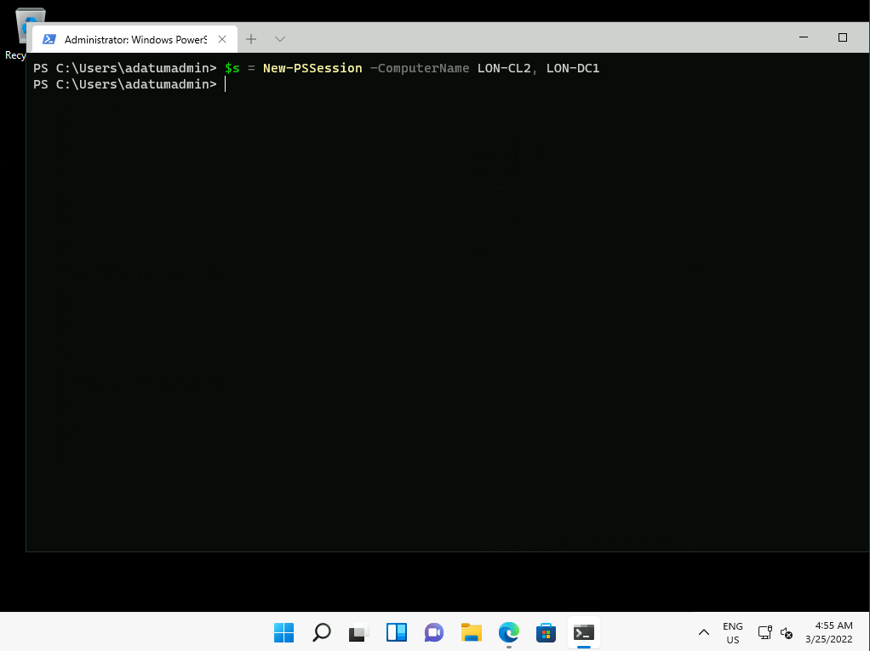

1. To retrieve a list of available PowerShell commands on both systems and assign the result to a variable, run the following command:
2. Invoke-Command -Session $s -ScriptBlock {$c = Get-command}

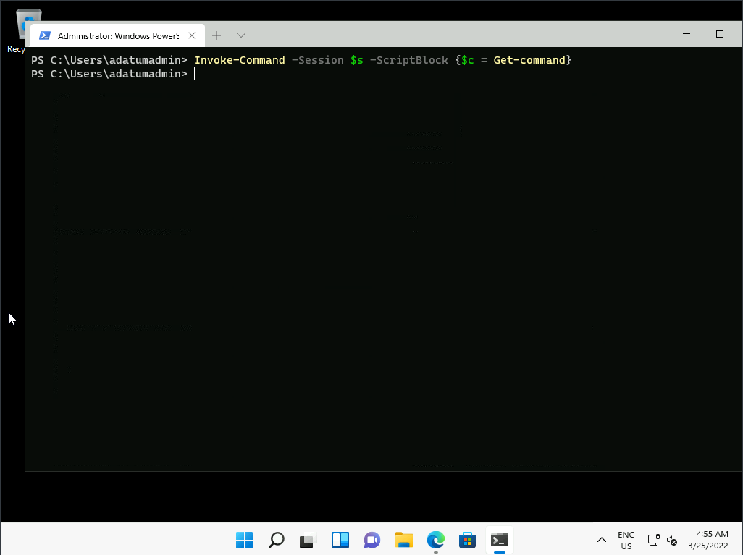

1. To count and display the number of commands stored in the c$ variable for each remote system, run the following command:
2. Invoke-Command -Session $s -ScriptBlock {$c.count}

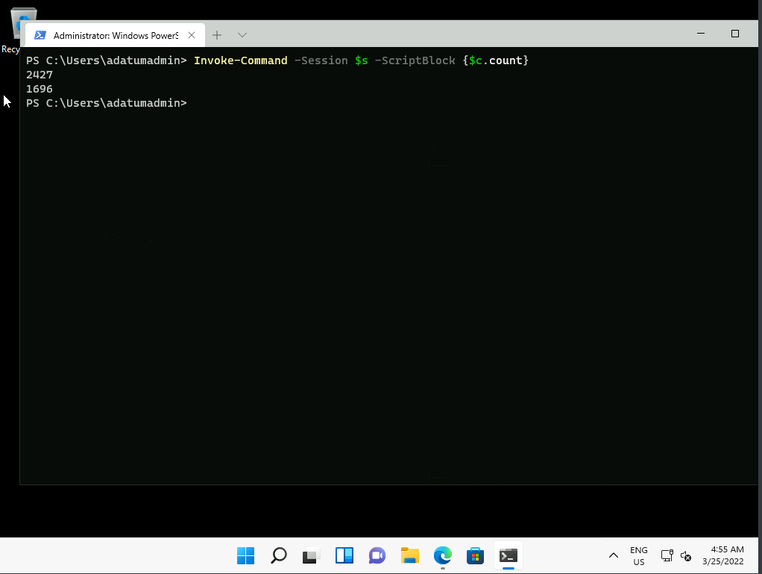

1. To restart a remote computer, run the following command:
2. Invoke-Command –ComputerName LON-CL2 –ScriptBlock {restart-computer -force}

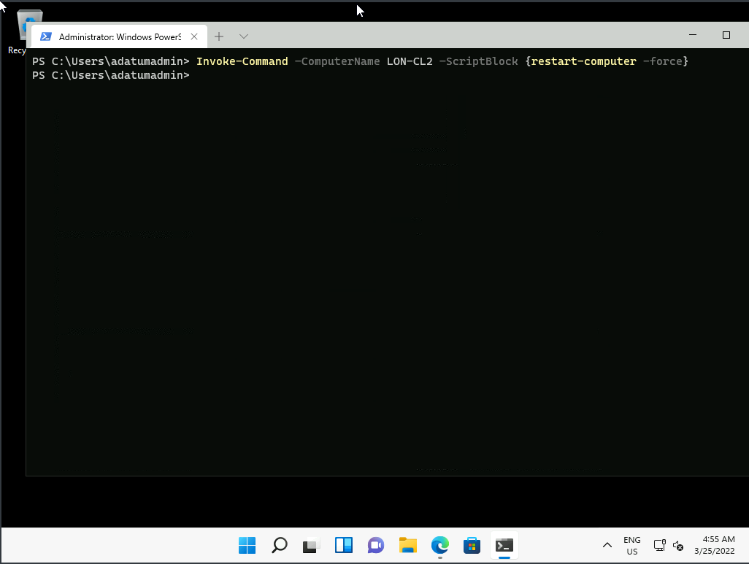

1. Switch to the [**LON-CL2**](urn:gd:lg:a:select-vm) Virtual Machine. It should be restarting.

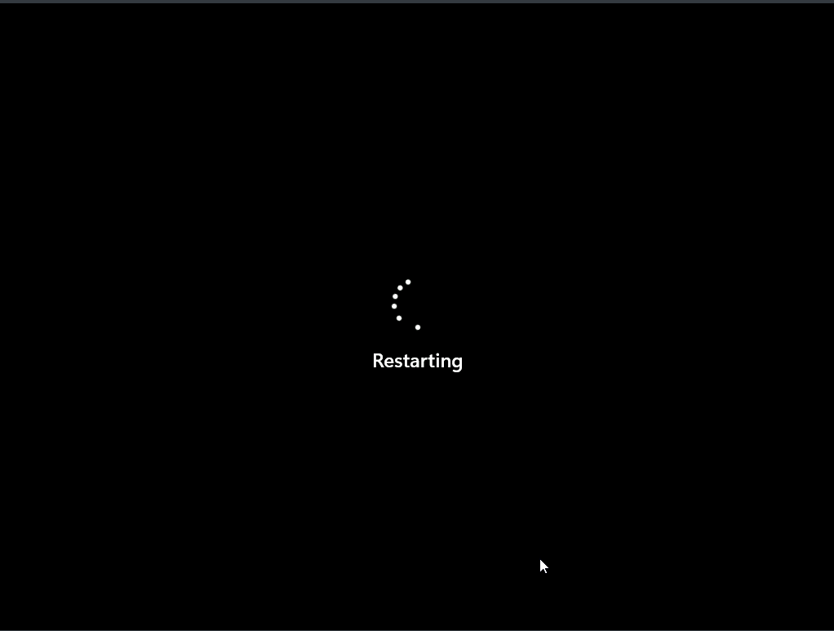

**Results**: After completing this exercise, you should have successfully configured the device with Windows PowerShell.

**Congratulations!** You have now completed this lab. To continue to the next lab click End Lab in the Tools Menu . If you wish to contiue with this lab at a later date ensure you save the lab environment rather than ending it.